

I Want to Test my Y-DNA - What do I do?

Lesson 2. Testing your Y-DNA
Objective: Understand Y-DNA STR results and what they mean
Tools: This lesson will walk you through the steps required to order and take the Y-DNA STR test and interpret the results.
- Words and phrases in bold indicate important terminology. Please consult the glossary included with the course material.
- Click any entry in the Table of Contents to jump to that part of the lesson.
- Class notes are at the end of the lesson.

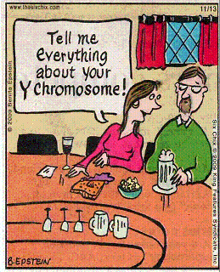

© 2009 - King Features Syndicate, Inc

Lesson written by Gale French
Version 1.2 (Sept 2016)
Layout and Design Gale French, Mesa Foard and Karin Corbeil
© 2014-2016 Gale French, DNAAdoption.com and DNAGedcom.com

Contents
Section 1. Ordering the Y-DNA Test 3
Go to FT-DNA 3
Surname Project 4
Section 2. Taking the Y-DNA Test 5
2.1 What to Expect - your kit 5
2.2 The Cheek Swab 5
2.3 Return 5
Section 3. Y-DNA Results 6
3.1 Get a Projected Date 6
3.2 Results e-Mail 6
3.3 Your Test Results 7
3.3.1 My DNA Page 7
3.3.2 DNA Matches Page 7
3.3.3 Y-DNA STR Values Page 8
3.3.4 Print Certificates Page 8
3.3.5 Haplogroup Origins Page 9
3.3.6 Haplotree & SNPs Page 10
3.4 Phylogenetic Tree 11
Section 4. Surname Projects 12
4.1 FT-DNA Surname Projects 12
4.2 Surname Project Page 12
4.3 Surname Project Results 13
4.4 World Families Projects 14
Section 5. Glossary 15
Section 6. Resources 16
Internet 16
Videos 16
Books 16
Section 7. Pop Quiz Answers 17
Section 8. Epilogue 18
Class Notes 18

Section 1. Ordering the Y-DNA Test
Here’s a step-by-step process to take and mange your Y-DNA test and results.

Go to FT-DNA
Start your browser and go to FamilyTree DNA (FamilyTreeDNA.com). Click on the 'Projects' tab at the top of the screen and then click on the 1st letter of your surname. Search to see if there is a Surname Project for your surname.

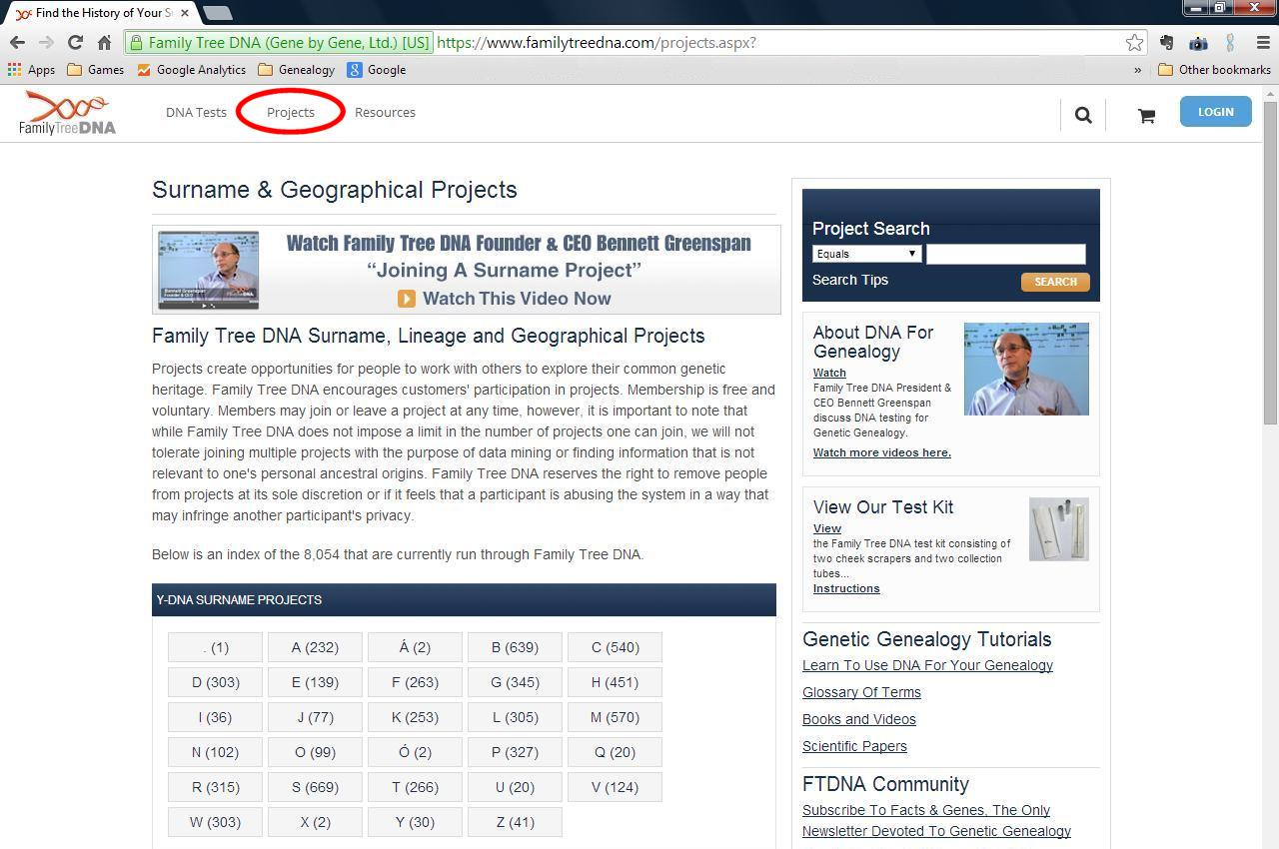

Either search for your surname or scroll down the list to browse through all the names.
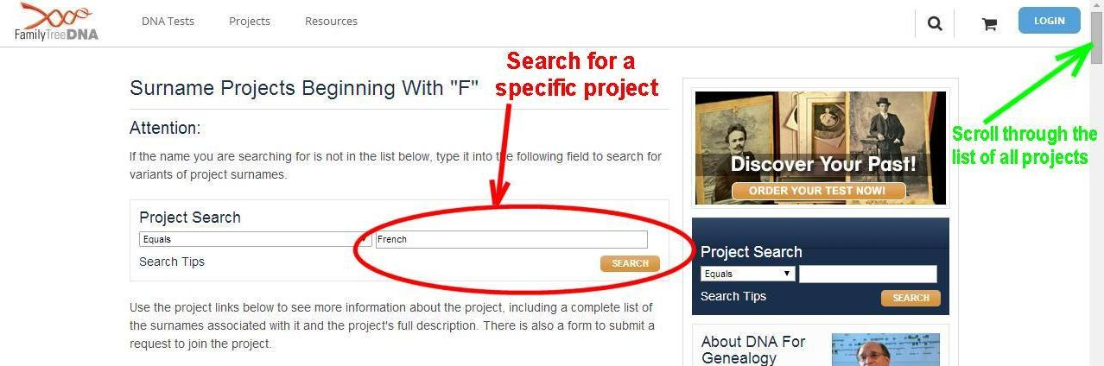

Discount!!!
When you order your test through a Surname Project, you get a discounted price!

Genome
The word “genome” is comprised of the words “gene” and “chromosome” to describe the entire genetic code of a human.

Surname Project
Members of a Surname project get a discount for ordering though the project.
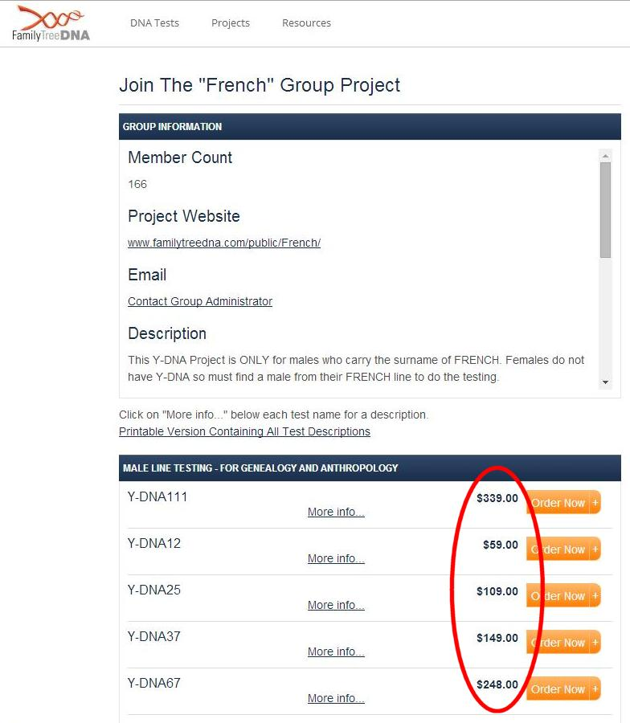 | 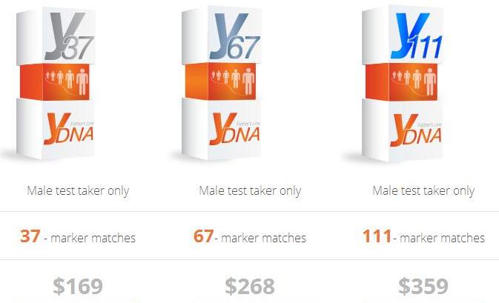

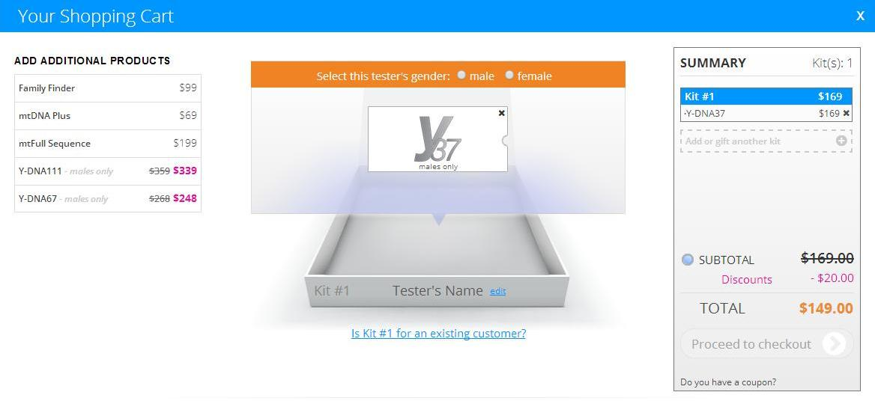


Section 2. Taking the Y-DNA Test
You will get an e-Mail confirming your order (with your Kit# and password). And now you wait!

2.1 What to Expect - your kit
A kit is for use by one person. It consists of two swabs, two tubes, instructions, the release form and a padded return envelope.
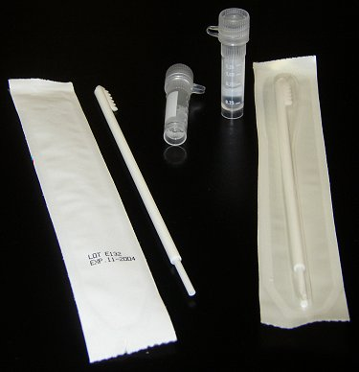 | 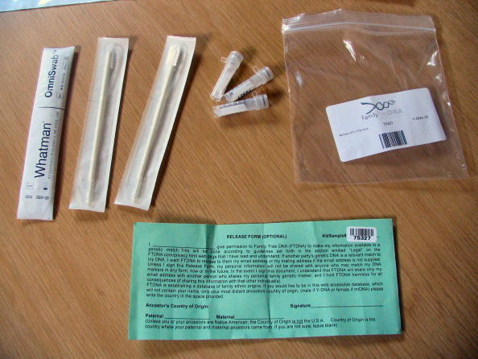

2.2 The Cheek Swab
Each swab has a cotton ‘toothed’ tip. Using it feels like brushing your inner cheek with your toothbrush. A good scrape produces lots of DNA. This makes the DNA extraction process easier. It is recommended that you wait 4 hours between the tests of each swab. Follow all the instructions! There is a great You-Tube video showing someone performing a DNA test:
https://www.youtube.com/watch?v=AN07Adpu7Bs
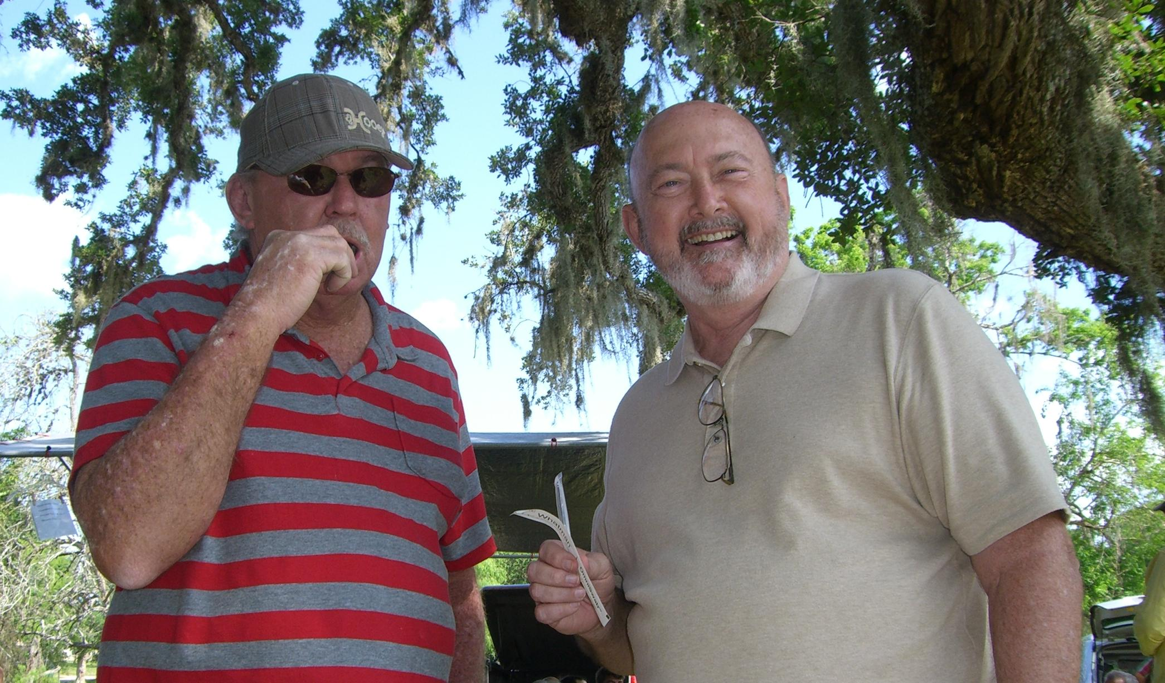
Figure 1 - Family Reunions are a great place to get relatives to test!

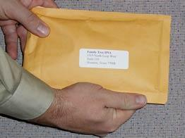
2.3 Return
Once you have done both swab tests, fill out and sign the release, pack the bag with the tubes and release form then mail it back. The current test kits come with return postage included!

Section 3. Y-DNA Results
You will get an e-Mail that your kit was received. And now you wait some more!
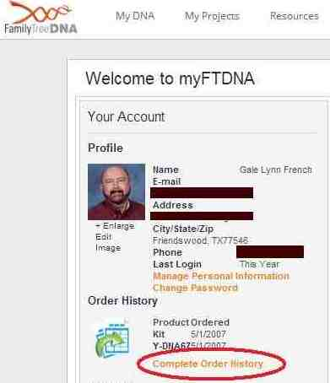

3.1 Get a Projected Date
You can get an estimated time for your results by logging on to FT-DNA and clicking on the 'Complete Order History' link.
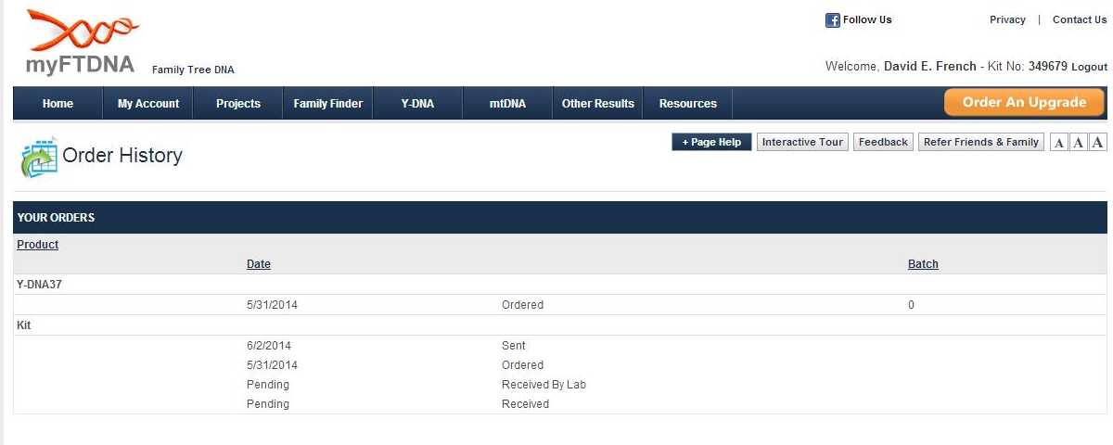
What to do while you wait
While you wait for your results to come in, stay busy with these activities:
Get your "paper" genealogy data for your paternal line in order
Think of other male family members to test to meet your objective(s)
Study Y-DNA resources listed here and others on the Web
Fill out your personal profile on FT-DNA

3.2 Results e-Mail
Soon you will get an e-Mail that your results are in; you may get partial results if you are getting a large number of markers tested (e.g., 38-47 of 67).
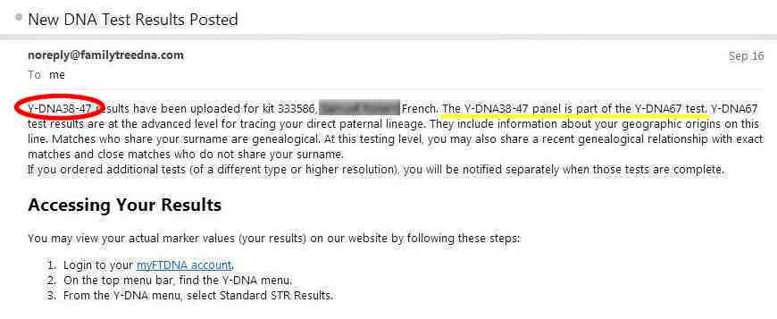

3.3 Your Test Results

3.3.1 My DNA Page
Once your results are in, you can logon and see your 'My DNA' page. For a Y-DNA test you will see your Haplogroup (in this example, R-M512) and various buttons to see other information.

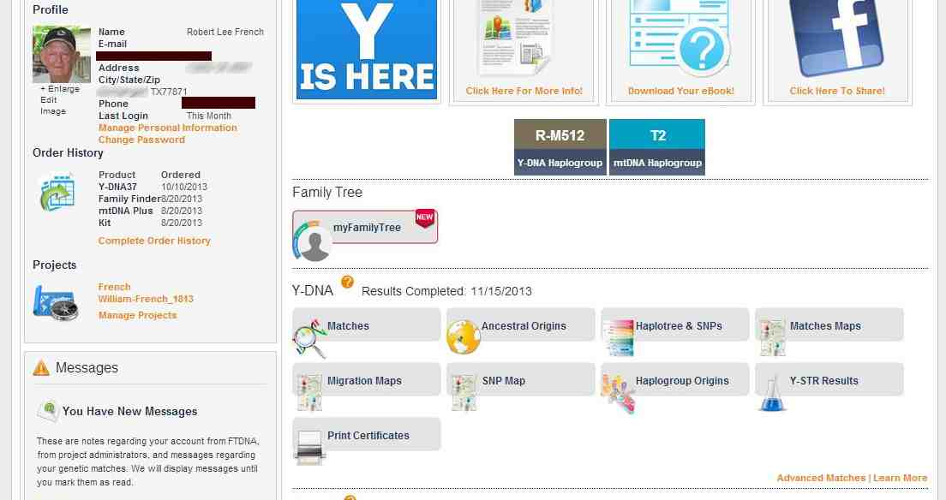
Figure 2 - My DNA page

3.3.2 DNA Matches Page
Probably of most interest is the Matches page. It gives you the name of the match, the number of markers they tested, their Genetic Distance, their Most Distant Ancestor known, their Haplogroup and the match date.

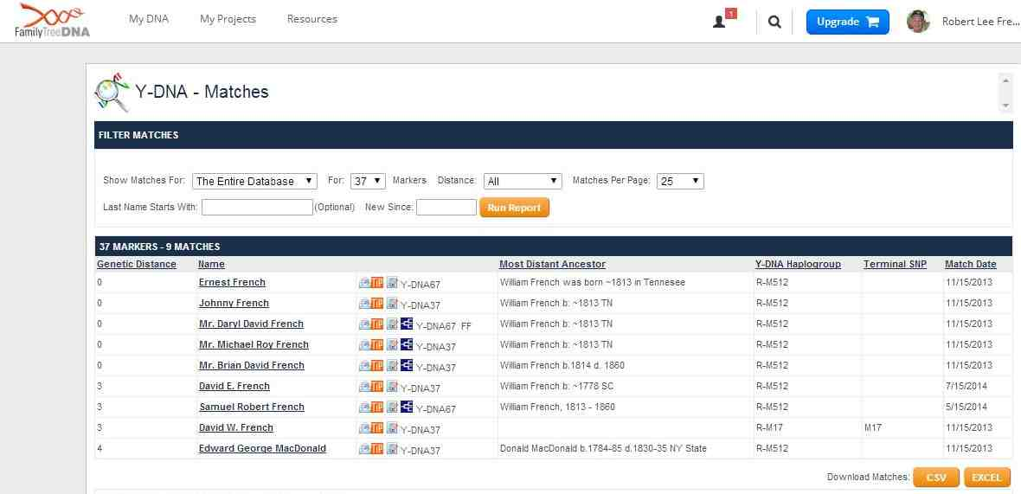
Default Number of Markers
The default number of markers shown will be the max number of markers that YOU tested (e.g., 37 in this case)

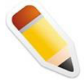
Pop Quiz #1
I'm a male named Smith researching a surname line that came from a female ancestor named Jones. Can I use the Y-DNA test to find if I match Jones?

Matches Icons
- - Send this person an e-Mail
- - View the TIP Report
- - Add a note about this person
- - This person has a Family Tree that you can view

3.3.3 Y-DNA STR Values Page
This page shows the allele values for each of the DYS markers on your test. This page also allows you to download these values to an Excel or .CSV file (useful if you are keeping your own record of family matches separate from a Surname project).
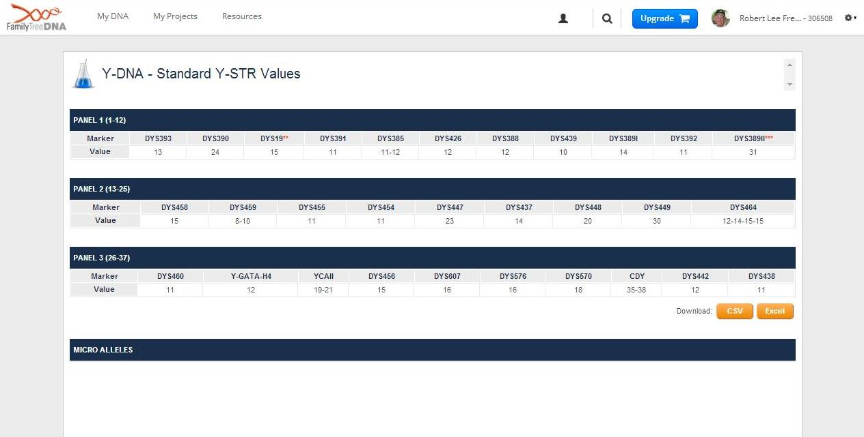
Pop Quiz #1
What is the minimum number of markers that I should test for examining paternal lineage?

3.3.4 Print Certificates Page
There are three certificates (PDF files) that you can review/print if you like; the most important is the #3 STR results:
- Understanding Your Results - a document on how to read and comprehend your results
- Y-DNA Migration Map - a generic map of Haplogroup migration paths
- Y-DNA STR Certificate - a "pretty" listing of your Y-DNA results

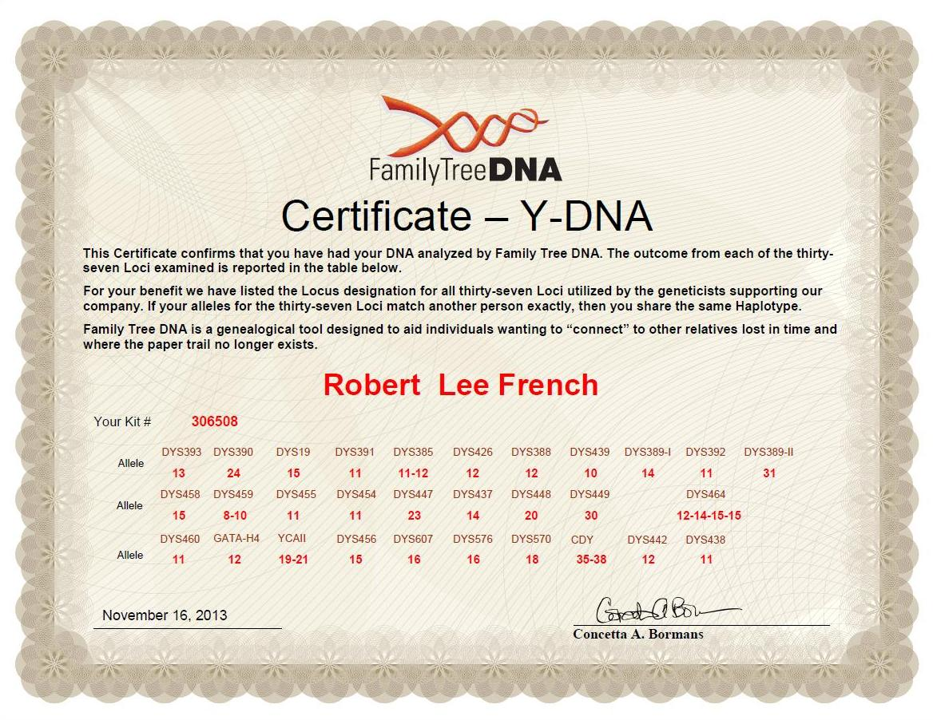

3.3.5 Haplogroup Origins Page
Depending on your Haplogroup, this page tries to narrow down the "country of origin" of the haplogroup. It shows how many of your matches (exact and different Genetic Distances) are from what countries. Buying additional SNPs (single nucleotide polymorphism) will allow you to identify "sub-clades" of your haplogroup (e.g., R-CTS4179 that means from 'Scotland') .
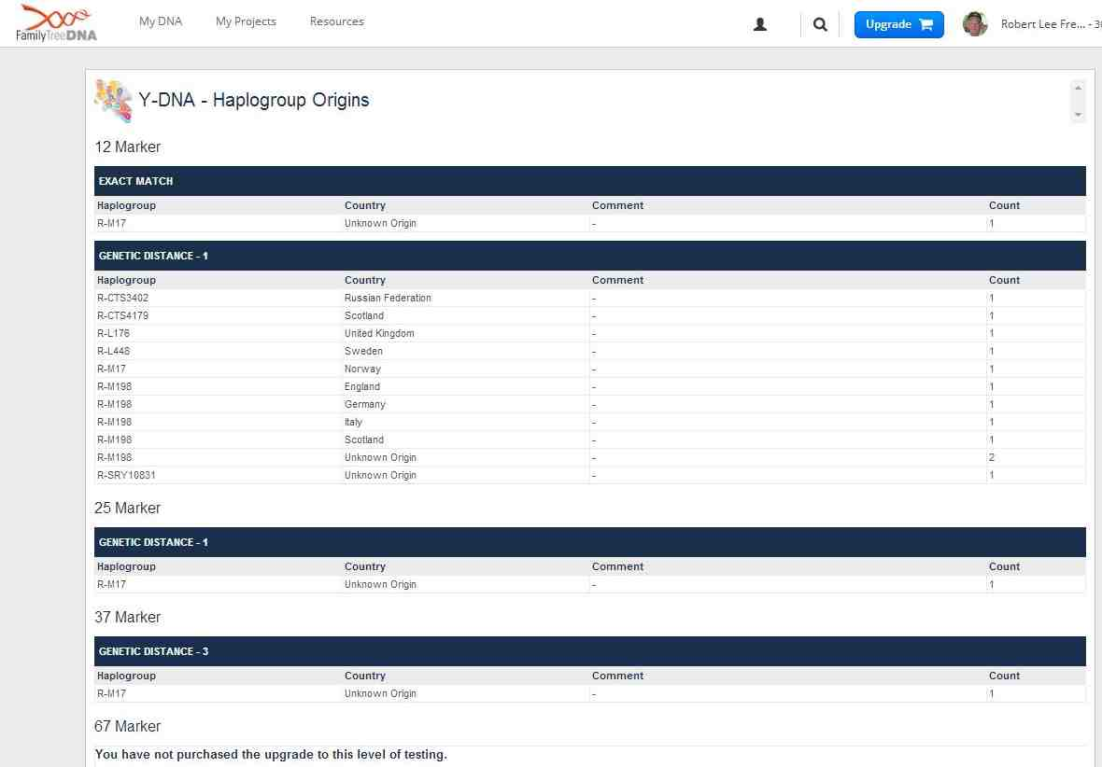

3.3.6 Haplotree & SNPs Page
This page allows you to view your Y-DNA SNP results and your haplogroup information. It tells whether this haplogroup is 'Confirmed' or 'Predicted'. This is a graphic tree that shows your placement on the current Y-Chromosome phylogenetic tree. In this example, the predicted Haplogroup is M-512.

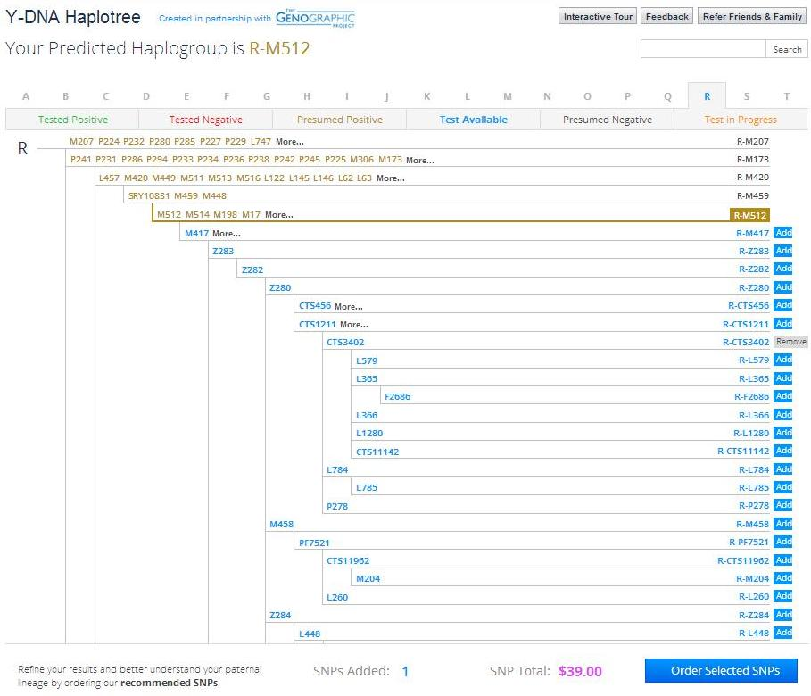

You may order individual SNPs that are part of the official Y-Chromosome Consortium tree for your haplogroup. You may also order (if your haplogroup is 'Predicted') by clicking on the suggested 'Add' buttons for each of the SNPs you wish to test. Your Project administrator (or Haplogroup Project Admin) can usually recommend which SNPs you should test.
Project Administrators
FT-DNA Project Administrators are unpaid volunteers that donate their time and experience to help users understand their results and where they "fit" in the paternal DNA picture puzzle.

3.4 Phylogenetic Tree
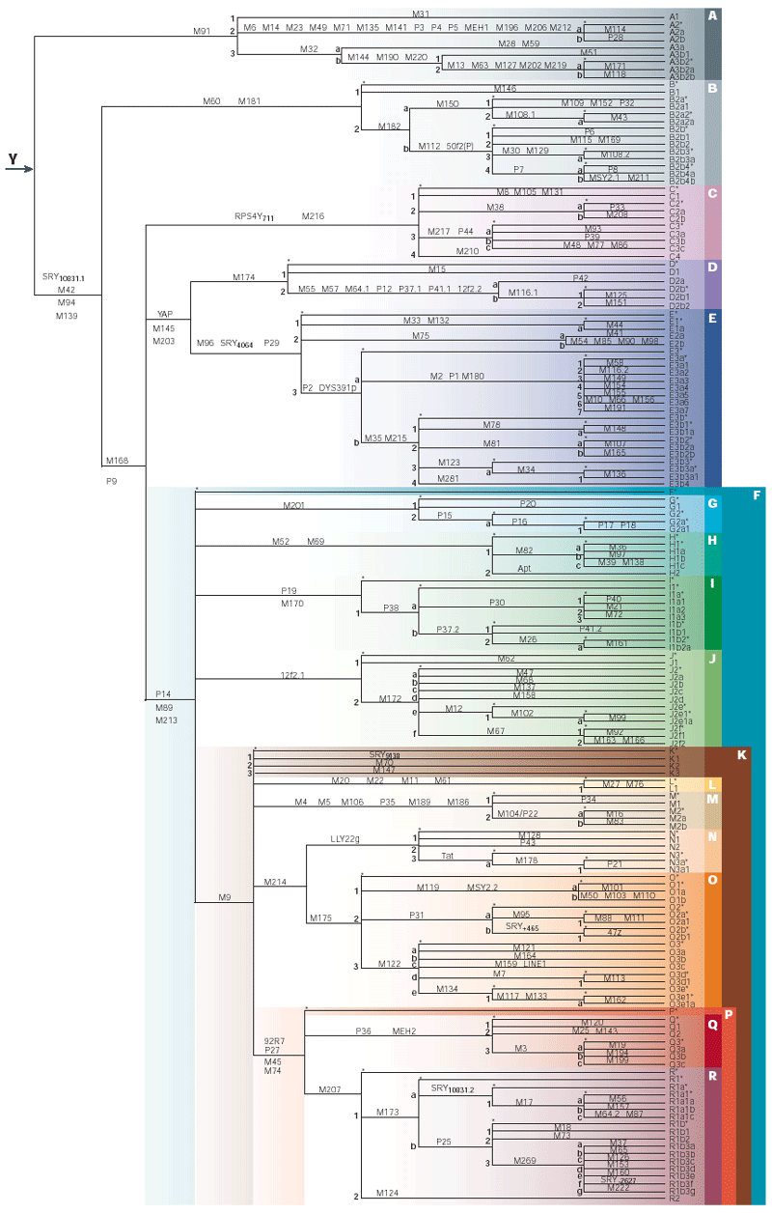

Section 4. Surname Projects

4.1 FT-DNA Surname Projects
Surname projects are an opportunity to work with others with similar DNA results to explore your paternal genetic heritage. Membership is FREE and voluntary. You may join or leave a project at any time. You may join as many projects as you wish:
- Surname
- Geographic
- Haplogroup

If you ordered your test through a surname project, you are already a member of that project.

4.2 Surname Project Page
Your results will automatically be reported to the Project Administrator for your surname. They may do some analysis and processing to determine if your results match a particular "Group" of results with similar Haplogroups and/or Common Ancestor names. Reach the group by clicking on one of your Projects from your 'My DNA' page (see Figure 2 - My DNA page on page 9) or by searching through the surname projects page (from Lesson #1). You'll see a page describing the project with links to results of various kinds.

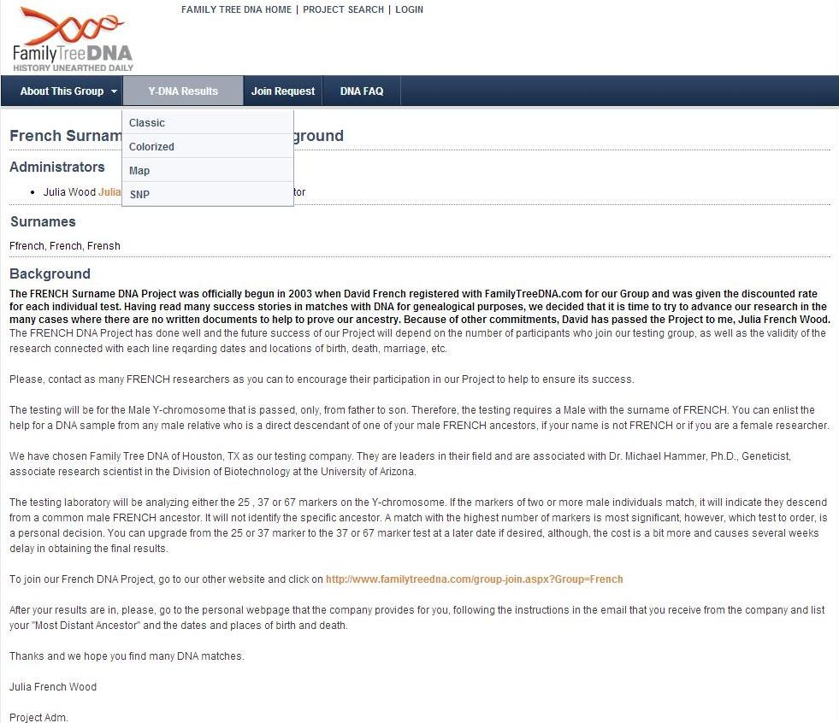

4.3 Surname Project Results
The most exciting data in the surname project lies in the Y-DNA Results page. Here you see the entire list of people that have tested for this surname. They have usually been grouped with members with similar characteristics. Some also color code the differences in allele values by highlighting them.

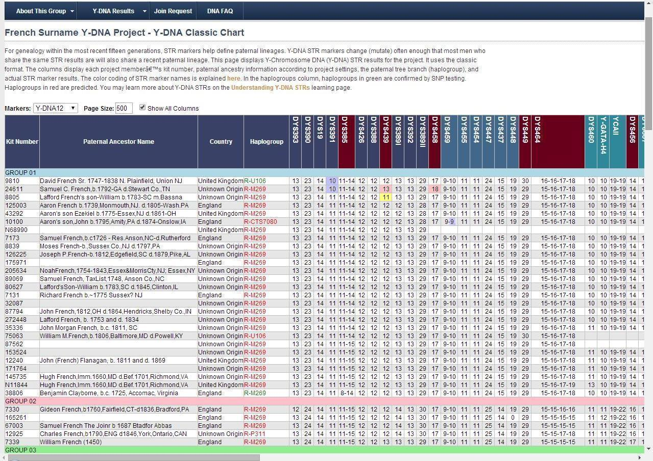

The color codes for the DYS headers at the top of the page are explained in the following chart:

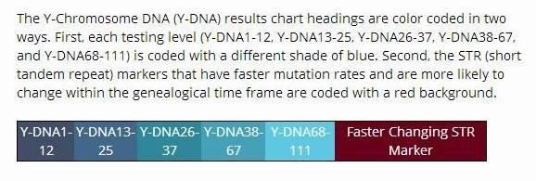
Pop Quiz #2
If I have a highlighted allele value on one or more of my markers, can my Genetic Distance be zero?

4.4 World Families Projects
Some Surname Projects at FT-DNA may be hosted at World Familes.net (http://www.worldfamilies.net). The link at FT-DNA will take you there or you can go there directly.
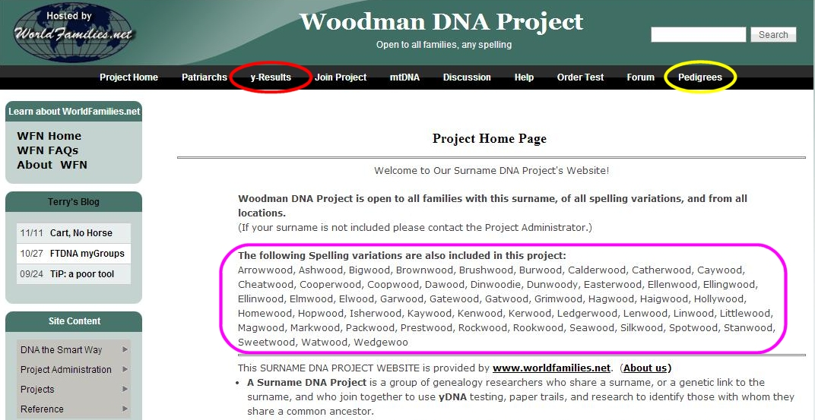
You can look at Y-Results (much like shown in Section 4.3). You can also see any user submitted pedigrees that were posted on the Forum for that surname (see example below) to see if they match your ancestor.
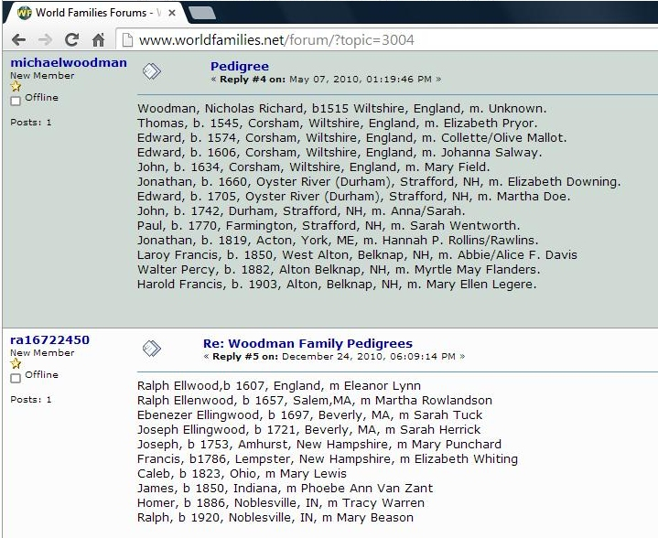

Section 5. Glossary

- Allele - One of the possible values for a marker. For example, with Y chromosome DNA, the values of "13" or "14" would be different alleles for DYS393.
- Base - A base is a unit or building block of DNA. Adenine (A), cytosine (C), guanine (G), and thymine (T) are the four primary bases in DNA. The order of bases is the sequence of DNA.
- Genetic Distance - Genetic Distance is the number of differences, or mutations, between two sets of results. A genetic distance of zero means there are no differences in the results being compared against one another
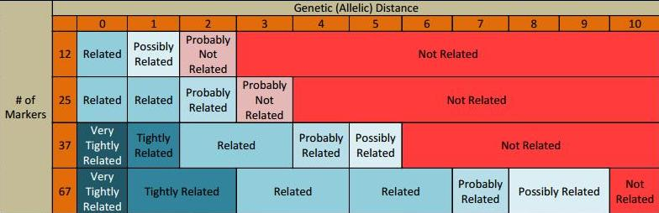
- Haplogroup - A haplogroup is a major branch on either the maternal or paternal tree of humankind. Haplogroups are associated with early human migrations. Today these can associated with a geographic region or regions.
- Haplotype - A haplotype is the set of DNA values. For example, the results of the Y-DNA12 test for one person are their haplotype.
- Marker - A marker is a physical location (locus) on the chromosome. The term is often used colloquially in genetic genealogy to refer to a short tandem repeat (STR).
- Most Distant Ancestor - the person along your paternal line that your paper research shows as the "oldest" male ancestor you have found
- Most Recent Common Ancestor (MRCA) - the most recent ancestor from which the two individuals descended
- Short Tandem Repeat (STR) - A short DNA motif (pattern) repeated in tandem. ATGC repeated eleven times would give the marker a value or allele of 11.
- Sub-clade - term used to describe a subgroup of a subgenus of a haplogroup.
- Y-Chromosome - One of the two sex chromosomes, X and Y. The Y-Chromosome passes down from father to son. Females do not receive it. As the Y-Chromosome is passed on through the paternal line, it is valuable for surname based genealogy studies.
- Y-DNA Backbone test - If a person’s Y-DNA haplogroup cannot be predicted with 100% confidence, the SNP Assurance Program at FTDNA will test your sample with our Backbone SNP test for FREE. This test is a "deep" multiple SNP test. Specifically, if we cannot predict a person’s Y-DNA haplogroup with sufficient confidence that they can join the National Geographic’s Genographic Project, we will automatically perform a Backbone SNP test in order to identify the haplogroup assignment. Backbone tests take about 6-8 weeks from the time they are ordered.

Section 6. Resources
Once you have clues to people who might match your DNA, there are gold mines of resources just waiting to help you move farther along in your search.

Internet
- The resources we’ve used in class, of course: FamilyTreeDNA.com.
- https://www.familytreedna.com/learn/using-the-kit/family-tree-dna-test-kit/
- https://www.familytreedna.com/learn/dna-test-kit-instructions/
- https://www.familytreedna.com/learn/using-the-kit/use-swabs/
- ISOGG: http://www.isogg.org
- There are many surname project websites, often associated with Y-DNA tests. Here’s one example: http://freepages.genealogy.rootsweb.ancestry.com/~woodydnaproject/index.htm .
- If you haven’t found what you want yet, visit Cindy’s List http://www.cyndislist.com/ for an incredible list of genealogy resources organized by category.

Videos
- https://www.youtube.com/watch?v=AN07Adpu7Bs How to Take a Family Tree DNA Test (4:10)
- https://www.youtube.com/watch?v=ekB9LY_aL04 Family Tree DNA Results Explained: Y-DNA Markers, Matching & Genealogy (FT-DNA Webinar 1:55:40)

Books
- Aulicino, Emily - "Genetic Genealogy: The Basics and Beyond", ©2014, AuthorHouse LLC, Bloomington, IN [ISBN13: 9781491840900]
- Smolenyak, Megan & Turner, Ann - "Trace Your Roots With DNA: Use Your DNA to Complete Your Family Tree", ©2004, Rodel Books, New York [ISBN 1594860068 (ISBN13: 9781594860065)]
- Pomery, Chris - "DNA and family history : how genetic testing can advance your genealogical research", ©2004, Dundurn Group, Toronto, Ontario
- Dowell, David R. (Ph.D.) - " NextGen Genealogy: The DNA Connection", ©2015, Santa Barbara, California : LIBRARIES UNLIMITED, an imprint of ABC-CLIO, LLC
- Hill, Richard - "Finding family : my search for roots and the secrets in my DNA", ©2012, Richard Hill (self published), Grand Rapids, Michigan. << available as book or e-Book>>

Section 7. Pop Quiz Answers
- 37 - Test only what you need (or can afford) and upgrade when necessary. The following chart shows the times back to the Most Recent Common Ancestor (MRCA) when ALL the markers match. So you get more "bang for the buck" by testing 37 markers in order to identify (or verify) most recent ancestors.

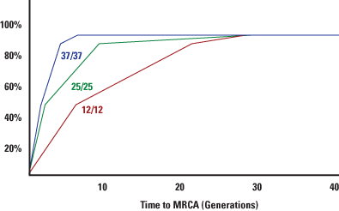

Remember from Lesson #1, with 37/37 (all 37 markers match), there is a 50% probability that the MRCA was no longer than 2 generations past, and a 90% probability that the MRCA was within the last 5 generations.

- No. With each highlighted difference, that increases your Genetic Distance (by one or more!). See definition of Genetic Distance in the Glossary.

Section 8. Epilogue

Class Notes

Summary
Y-DNA can trace the origins of a surname and can be used to find other people who shared an ancestor on this paternal line. Y-DNA Testing is the process of getting your Y-Chromosome results for comparing with other testers.

Access to Materials
Your Moodle login will continue to be available to you. If you’d like to retake the class, you are welcome to sign up as space is available. No additional donation will be requested (although they are certainly welcome!). Email moodle@dnaadoption.com if you wish to re-take this class.
Class Forum
The class forum will be available for follow-up questions for an additional 4 weeks subsequent to the posting of Lesson 3. Participants will also have the option of re-taking this class for free within the next year. Contact moodle@dnaadoption.com if you wish to re-take this class.

Stay in Touch! Let us know how your journey is going.
moodle@dnaadoption.com

NOTE: the Glossary "grows" with each lesson (and includes definitions from previous lessons) so that you don't have to go back to other Lessons to get definitions.

