

**Introduction: Y-DNA Introduction (or Who's your Daddy?)**

**Lesson 1. Introduction to Y-DNA**

**Objective:** Understand **STR** Y-DNA and how it affects your genealogy

**Tools:** This lesson will introduce you to Y-DNA and how it is used in genealogy.

* Words and phrases in **bold** indicate important terminology. Please consult the glossary included with the course material.
* Click any entry in the Table of Contents to jump to that part of the lesson.
* Class notes are at the end of the lesson.

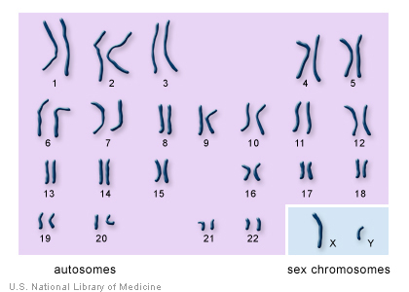

Lesson written by Gale French

Version 1.9 (Feb. 2021)

Layout and Design Gale French, Mesa Foard and Karin Corbeil

© 2014-2021 Gale French, DNAAdoption.org and DNAGedcom.com

Contents

Section 1. DNA: Introduction to Basic Genetics 3

We’re all related 3

Section 2. DNA Basics 5

Types of DNA 5

What is X-DNA? 6

DNA Comparison - Y & mtDNA 7

Section 3. Y-DNA 8

DNA Composition 8

STR Markers 8

STR Marker Tests 9

Y-DNA Genetic Distance 9

Section 4. Y-DNA Testing 11

Why get Tested? 11

What gets Tested? 11

Where to get Tested 11

Kinds of Y-DNA Tests 12

Y-STR 12

Y-SNP 12

Big-Y 12

Haplogroup 12

Surnames 12

Section 5. Glossary 13

Section 6. Resources 14

Internet 14

Books 14

You 14

Section 7. Pop Quiz Answers 15

Section 8. Epilogue 16

Class Notes 16

# Section 1. DNA: Introduction to Basic Genetics

*Here’s a simplified overview of all the science you need to know to work with your DNA results.[1]*

## We’re all related

You are related to every human being on earth, making you a *bona fide* member of the species *Homo sapiens*. In fact, you share[2] 99.5% of your genetic makeup with your mom, your dad, the neighbor down the street, a baker in France -- even the Pope!

That’s because of deoxyribonucleic acid (**DNA)**. DNA contains the instructions that form and maintain living organisms. It tells apples to become apples, dogs to become dogs and humans to become – you guessed it – humans.

But what makes an apple green or red? A dog black or spotted? Your eyes brown or blue? **Genes** do. Genes are segments of DNA that are **coded** to determine traits. Each human has the same number of them – over 20,000 – which collectively form your **genome**.

All of this DNA is organized into cell delivery packages called **chromosomes** which are passed from parents to their offspring. A fruit fly has four chromosomes. A dog has 39**.** And you have 46.

You inherited 23 chromosomes from your mother and 23 from your dad. The last pair, the **allosomes,** are the sex chromosomes that determined your gender.

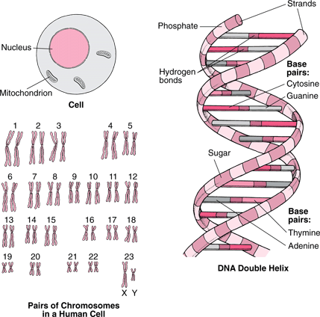

But what do those other 22 pairs of chromosomes do? These are the **autosomes**, and they determine everything else about a human other than gender.

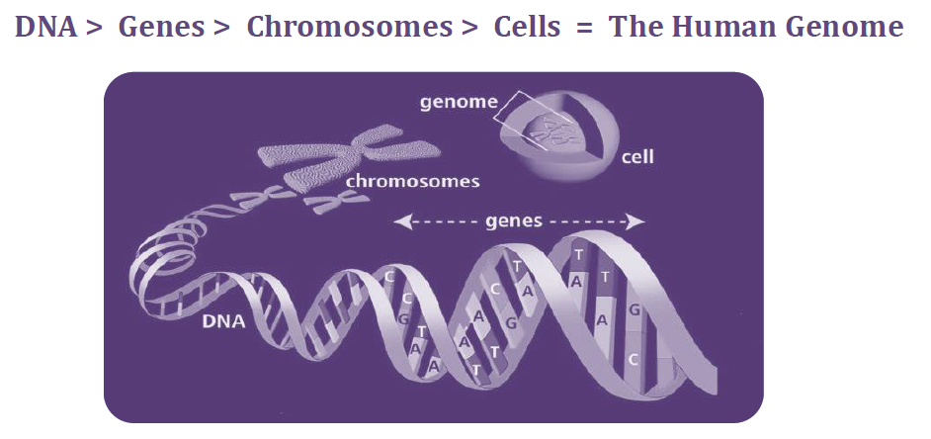

You may be thinking that if we’re all related, what makes us unique? What makes us biologically different from each other? Good question. It’s the combination of autosomal DNA (atDNA) in that little .5% which we inherited directly from our ancestors that makes us unique among the billions of other people on earth. **[3]**

**Genome**

The word “**genome**” is comprised of the words “gene” and “chromosome” to describe the entire genetic code of a human.



# Section 2. DNA Basics

## Types of DNA

There are four basic types of DNA used in genealogical testing:

1. Y-DNA - DNA derived from the Y Chromosome

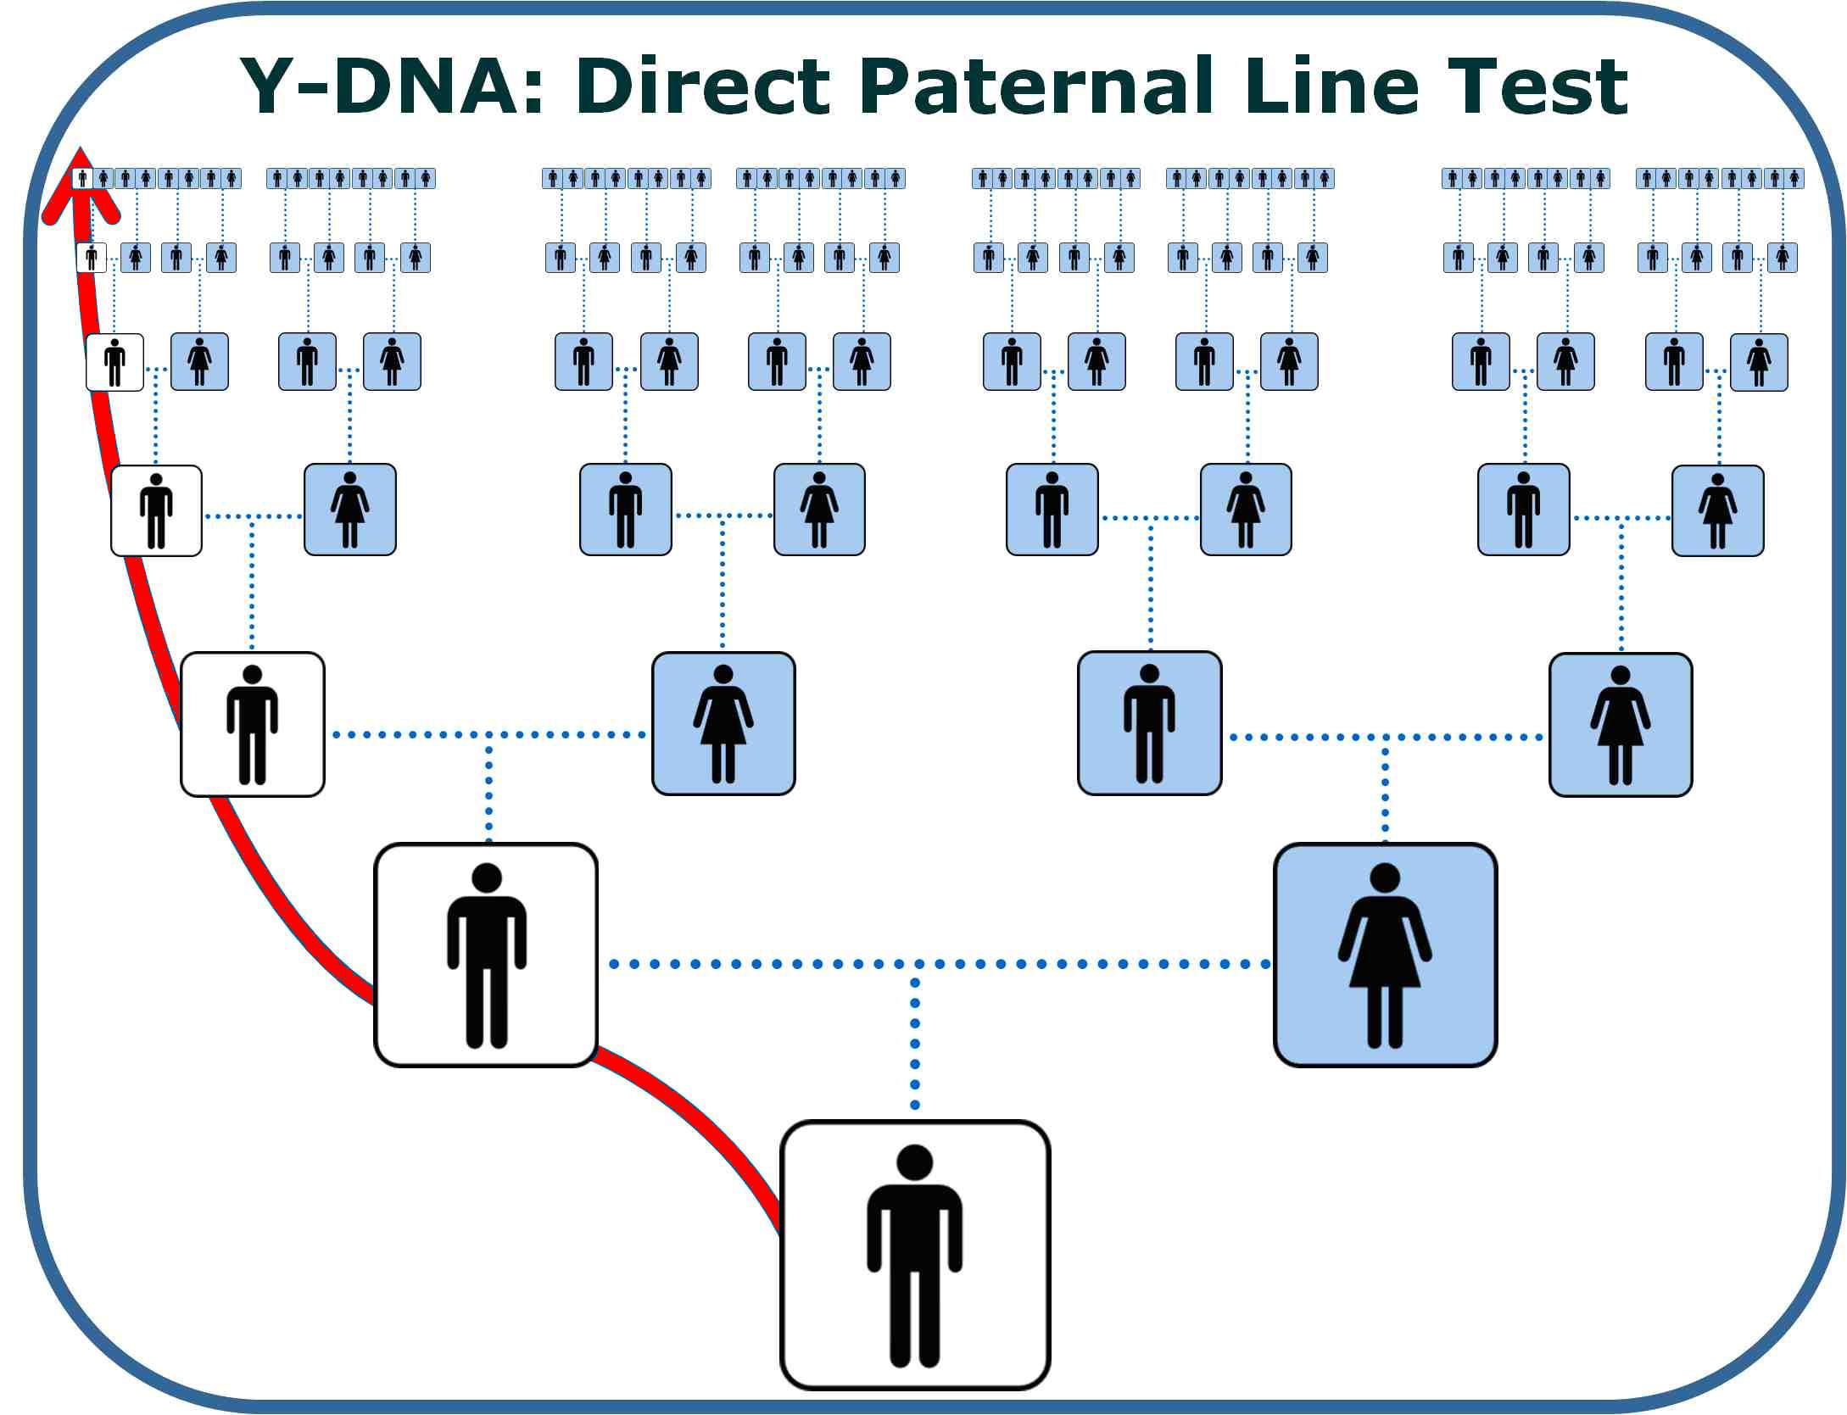

The Y-chromosome is only passed down from a father to a son, unchanged from generation to generation (unless a random naturally occurring change called a **mutation** happens). The result of that mutation (called a **marker**) can be traced through many generations as that man will pass it on to his sons, and to every male in the family for many generations. On average, mutations in any marker are estimated to occur only once in every 500 generations.

The Y-DNA **STR** test offers a clear path from you to a known, or likely, direct paternal ancestor(s).

1. mtDNA - **Mitochondrial** DNA

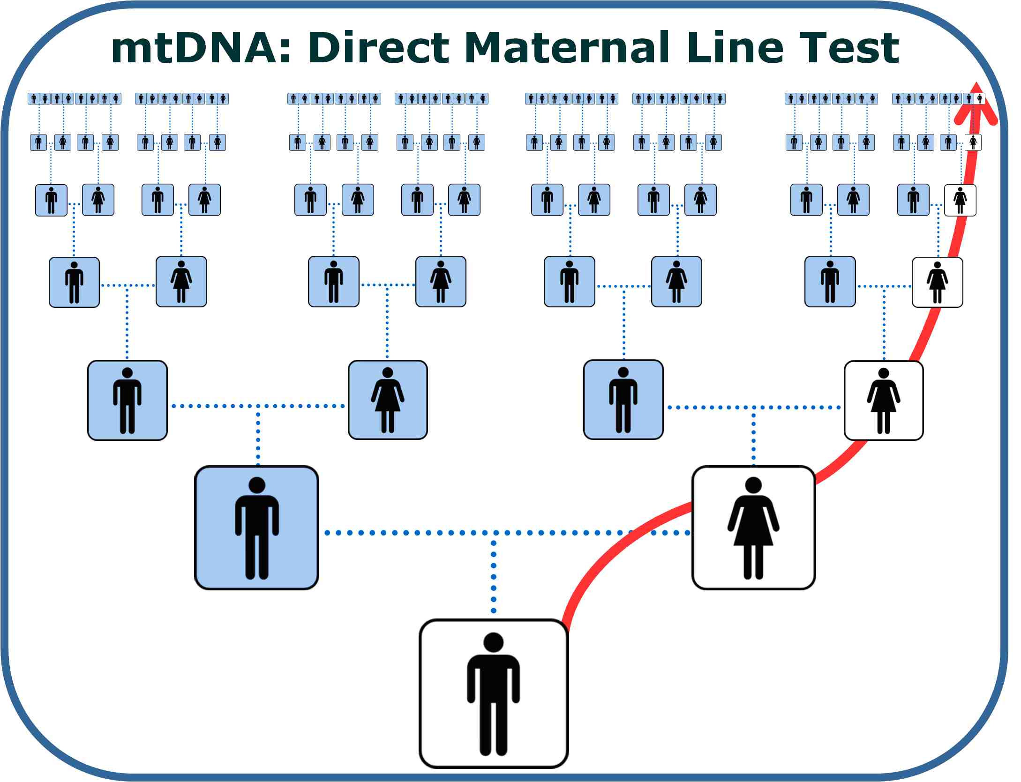

mtDNA is the line that follows your mother’s maternal ancestry. This line consists entirely of women, although both men and women have their mother’s mtDNA. This means that fathers do not pass on their mtDNA to their children. Your mtDNA can trace your mother, her mother, her mother’s mother, and so forth, and offers a clear path from you to a known, or likely, direct maternal ancestor.

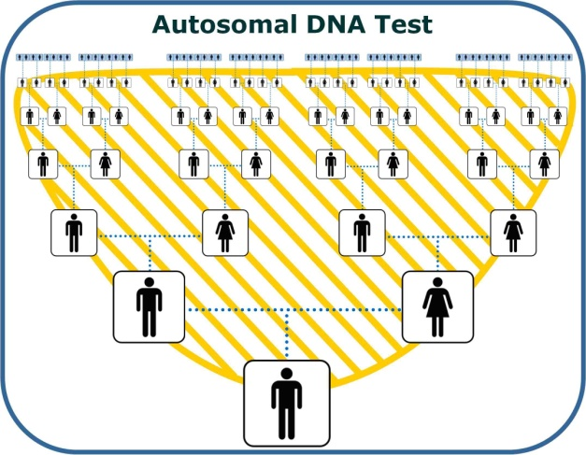

1. atDNA - **Autosomal** DNA

atDNA is inherited randomly; you will inherit segments that your mother passed on to you, some that your father passed to you, some from your grandparents and maybe even some from your paternal third great-grandmother.

This test is designed to find relatives on any of your ancestral lines within the last 5 generations.

1. X-DNA - **X-Chromosome DNA**

## What is X-DNA?

It is really quite simple. A man passes down his X chromosome only to his daughter. A woman passes down her X chromosome to both her sons and daughters. Now let’s reverse the picture. A man gets his chromosome from his mother, not his father. A woman gets hers from both her mother and father. We are saying the same thing, but one description might make more sense to you than the other.

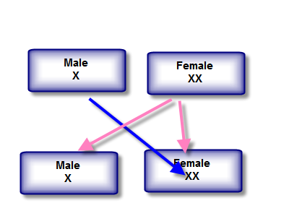

A male never gets an X from another male. The chart below[4] shows the X-Chromosome inheritance pattern (where blue is male and pink is female).

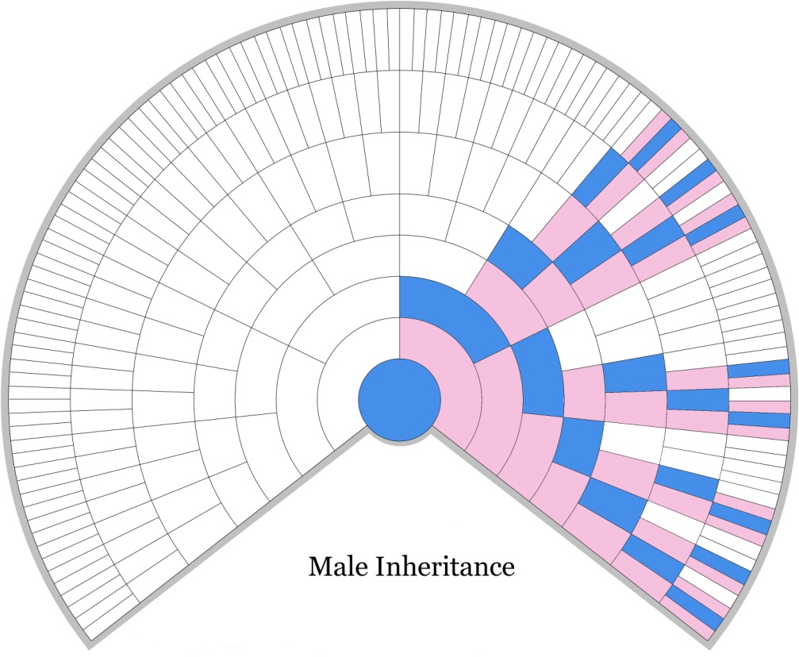

This lesson will concentrate on the **Y-DNA**.

**Pop Quiz #1**

I'm a male named Smith researching a surname line that came from a female ancestor named Jones. Can I use the Y-DNA test to find if I match Jones?



## DNA Comparison - Y & mtDNA

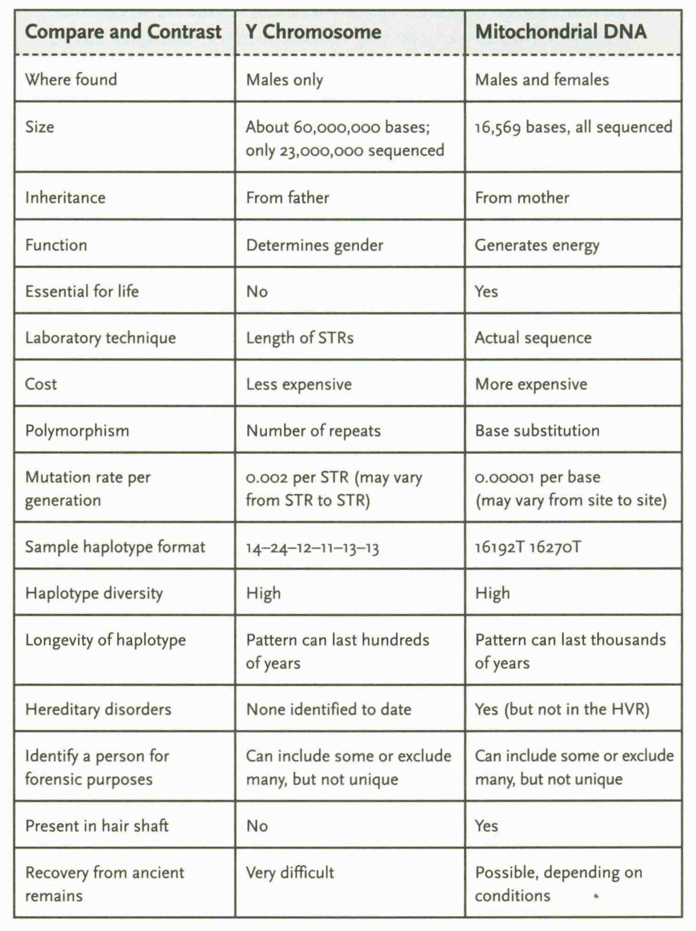

# Section 3. Y-DNA

## DNA Composition

The DNA helix consists of **base pairs** that attach to reproduce the DNA of a parent.

1. Adenine (A)
2. Thymine (T)
3. Guanine (G)
4. Cytosine (C)

|  |  |
| --- | --- |
| dnastructure | dna (AT-CG)  *c/o - SMGF* |

## STR Markers

A chromosome contains sequences of repeating nucleotides known as **Short Tandem Repeats** (**STRs**). The number of repetitions varies from one person to another and a particular number of repetitions are known as an **allele** value of the marker. An STR on the Y-chromosome is designated by a  **DYS** number (**D**NA **Y**‑chromosome **S**egment number).  For an STR test, short segments of DNA are measured. The number of **repeats** in that short sequence represent a marker value for a particular DYS. The outcome of the Y-DNA test is presented as a series of marker values and the results, or alleles which is called a **haplotype** (not to be confused with a **Haplogroup** covered later), as in the following 12-marker example:

|  |  |  |  |  |  |  |  |  |  |  |  |  |
| --- | --- | --- | --- | --- | --- | --- | --- | --- | --- | --- | --- | --- |
| **DYS#** | **393** | **390** | **19** | **391** | **385a** | **385b** | **426** | **388** | **439** | **389-1** | **392** | **389-2** |
| **Alleles** | 13 | 24 | 14 | 10 | 11 | 14 | **12** | 12 | 12 | 13 | 13 | 29 |

Someone with a result of 12 at DYS426 would have the following sequence:

…TGTGTTGTTGTTGTTGTTGTTGTTGT**TGTTGTTGTTGTT**GAC…

At each location on the Y-chromosome, there is the potential for some variation; at DYS426, the variation consists of 7 to 18 repeats of the DNA sequence “GTT”, with 12 being the most common. [5]

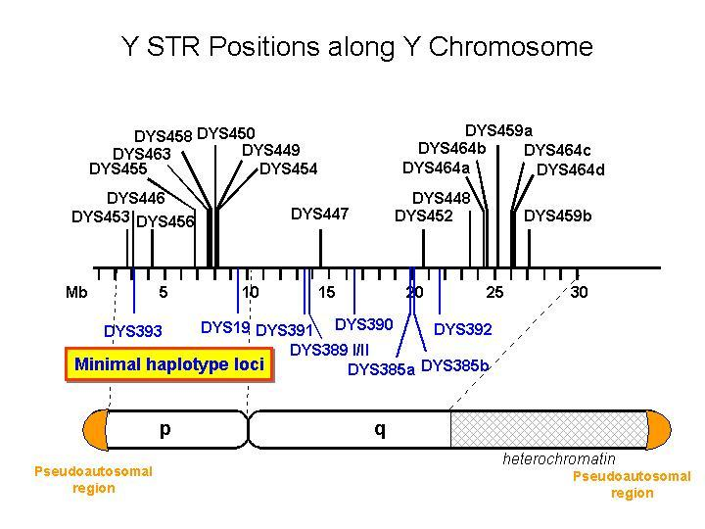

*c/o - FT-DNA*

## STR Marker Tests

The types of Y-DNA tests vary by the number of markers which are examined. There are:

1. 12 Marker (for use in limited cases)
2. 37 Marker (there used to be a 25 Marker test)
3. 67 Marker (now only available as an Upgrade)
4. 111 Marker

The more markers that are tested, provide a better possibility of identifying paternal matches for more generations. The fewer mismatches testers show, the shorter the time that has elapsed since their **Most Recent Common Ancestor** (**MRCA**). The goal is to find a person(s) that match the most markers with you. That means a very close relationship. It is recommended that you start testing with a minimum of 37 markers.

## Y-DNA Genetic Distance

When talking about two or more Y-Chromosome STR haplotypes, **Genetic Distance** is the total number of differences, or mutations, between two sets of results. The lower the number, the closer you are related. In general, it is found by summing the differences between each STR marker. For example, kit B111 and B222 have allele values of 29 and 28 respectively at DYS389-2. This is a difference of 1 {29-28= 1}. Because this is the only difference in their Y‑DNA12 profiles, their genetic distance is 1. It has nothing to do with Generations; just math!

|  |  |  |  |  |  |  |  |  |  |  |  |  |
| --- | --- | --- | --- | --- | --- | --- | --- | --- | --- | --- | --- | --- |
| Kit | Surname | D Y S 3 9 3 | D Y S 3 9 0 | D Y S 1 9 | D Y S 3 9 1 | D Y S 3 8 5 | D Y S 4 2 6 | D Y S 3 8 8 | D Y S 4 3 9 | D Y S 3 8 9 | 1 | D Y S 3 9 2 | D Y S 3 8 9 | 2 |
| B111 | Smith | 12 | 23 | 14 | 10 | 17-18 | 11 | 12 | 11 | 12 | 14 | **29** |
| B222 | Smith | 12 | 23 | 14 | 10 | 17-18 | 11 | 12 | 11 | 12 | 14 | **28** |
| B333 | Smythe | 12 | 22 | 14 | 10 | 16-17 | 11 | 12 | 11 | 12 | 14 | 29 |

**Pop Quiz #2**

What is the Genetic Distance between kit B222 and B333? (*be careful*!!)



At 67 markers, this table shows the probability that your common ancestor (MRCA) lived no longer than this number of generations ago.

|  |  |  |  |
| --- | --- | --- | --- |
| Genetic Distance | **50%** | **90%** | **95%** |
| 0 | 2 | 5 | 7 |
| 1 | 4 | 8 | 9 |
| 2 | 6 | 12 | 14 |

**Pop Quiz #3**

From the table above, in the case between kit B111 and B222 where the genetic distance was 1, what is the probability that their MRCA is within the last 4 generations?



The percent chance of a common ancestor within a given time is not an exact science, thus the calculations vary as the genetic distance grows. The following table refines the table above and shows the probability for multiple markers (the key for the 2nd row is: #markers/genetic dist. (e.g., 25/1 means 25 markers test with one difference):

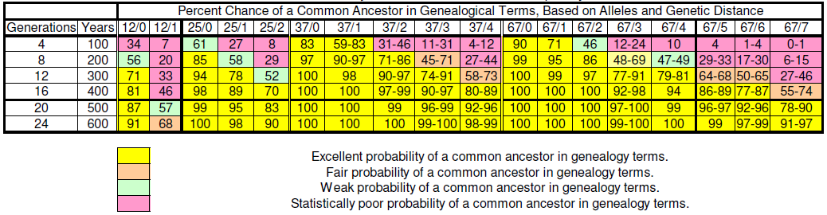

Do you see that the more markers tested increases your probability of finding a MRCA?

# Section 4. Y-DNA Testing

## Why get Tested?

The Y-DNA test is designed to trace the direct paternal line (your father's, father's, father's, etc.). Take the Y‑DNA test:

1. If you want to prove/validate a direct relationship with an ancestor for which you have a "paper" trail
2. If you want to match to a more distant ancestor in your line (past your own research) further than autosomal testing can
3. If you want to map the migration pattern or find the geographic origin of your **Haplogroup**
4. If your are adopted or don't know your biological father and want to find possible surnames/leads
5. To benefit others and preserve data for posterity

As an example of #1 and #2, I had done the "paper" research that took my paternal line back to William French [b:1813 TN] and was sure that his parents were William French [b:1780 SC] and Nancy Chapman. I had 'D.E.F' from a known son (Thomas J. French) of that pair test and the Y-DNA results verified the relationship with DNA! I both validated my research and extended my tree one level with the addition of William French [b:1780 SC].

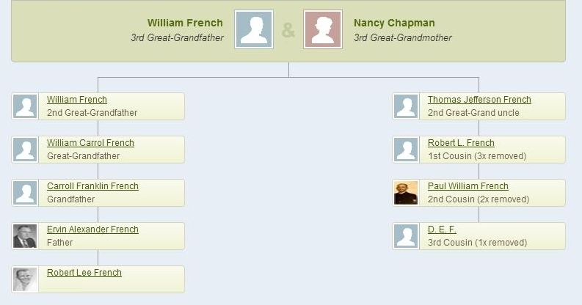

## What gets Tested?

Y-DNA testing[6] involves looking at Y-STR segments of DNA on the Y chromosome. The STR segments which are examined are referred to as **genetic markers** and occur in what is considered non-coding DNA or "*junk*" DNA.

## Where to get Tested

Today, the only[7] place to get Y-DNA STR testing is at Family Tree DNA ([FamilyTreeDNA.com](http://www.familytreedna.com/)). Lesson 2 will tell you what to do once you have your test results.

## Kinds of Y-DNA Tests

### Y-STR

Y-DNA **S**hort **T**andem **R**epeat (STR) testing tells about the most recent generations (1 to 45) of a male’s paternal heritage. This is the most common test taken.

### Y-SNP

**Single Nucleotide Polymorphisms** (**SNPs**) tell of the line’s deeper history and trace back to ancient times.

### Big-Y

The BIG Y test is a direct paternal lineage SNP test and an STR test. It's designed to explore deep ancestral links on our common paternal tree. It tests both thousands of known branch markers and millions of places where there may be new branch markers. It is intended for expert users with an interest in advancing science. [8]

## Haplogroup

The Y-DNA test will also give you your Y-haplogroup. A haplogroup is a set of similar **haplotypes** that share a common ancestor having the same single nucleotide polymorphism (SNP) mutation in all haplotypes. The haplogroup is shown as an alphanumeric code: e.g., R1a1a or (R-M512).

Haplogroup will be covered in more detail in Lesson 2.

## Surnames

Y-DNA usually follows the same inheritance pattern as surnames. As the surname is passed down from father to son, so is the Y-DNA. Because of this, males can often identify which direct paternal ancestral line to which he belongs by matching others with the same (or similar; e.g., Smith/Smythe) surnames.

We'll look at Surname Projects in Lesson 2.

**Pop Quiz #4**

I am a woman; can I take the Y-DNA test?



# Section 5. Glossary

* **Allele** - One of the possible values for a marker or a gene.
* **Base** - A base is a unit or building block of DNA. Adenine (A), cytosine (C), guanine (G), and thymine (T) are the four primary bases in DNA. The order of bases is the sequence of DNA.
* **Genetic Distance** - Genetic Distance is the number of differences, or mutations, between two sets of results. A genetic distance of zero means there are no differences in the results being compared against one another

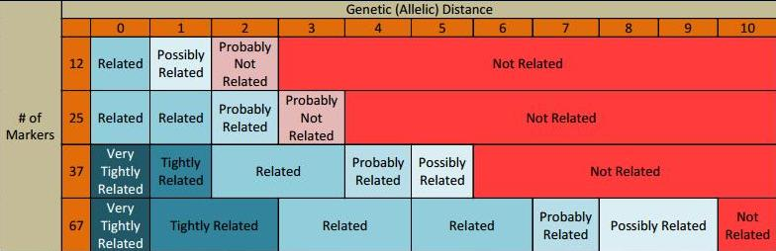

* **Haplogroup** - A haplogroup is a major branch on either the maternal or paternal tree of humankind based on the results of SNP testing. Haplogroups are associated with early human migrations. Today these can associated with a geographic region or regions.
* **Haplotype** - A haplotype is the set of values for a group of DNA test values. For example, the result of the Y‑DNA12 test for one person is their haplotype.
* **Locus** - A locus is a specific location in your genetic code. In a genetic map of our DNA, the locus tells us where to find any base. The plural of locus is loci.
* **Marker** - A marker is a physical location (locus) on the chromosome. The term is often used colloquially in genetic genealogy to refer to a short tandem repeat (STR).
* **Short Tandem Repeat (STR**) - A short DNA motif (pattern) repeated in tandem. ATGC repeated eleven times would give the marker a value or allele of 11.
* **Y-Chromosome** - One of the two sex chromosomes, X and Y. The Y-Chromosome passes down from father to son. Females do not receive it. As the Y-Chromosome is passed on through the paternal line, it is valuable for surname based genealogy studies.
* **Y-DNA Backbone test** - If a person’s Y-DNA haplogroup cannot be predicted with 100% confidence, the SNP Assurance Program at FTDNA will test your sample with our Backbone SNP test for FREE. This test is a "deep" multiple SNP test. Specifically, if we cannot predict a person’s Y-DNA haplogroup with sufficient confidence that they can join the National Geographic’s Genographic Project, we will automatically perform a Backbone SNP test in order to identify the haplogroup assignment. Backbone tests take about 6-8 weeks from the time they are ordered.

<https://dnaadoption.org/acronyms/>

<https://dnaadoption.org/glossary/>

# Section 6. Resources

Once you have clues to people who might match your DNA, there are gold mines of resources just waiting to help you move farther along in your search.

## Internet

* The resources we’ve used in class, of course: [FamilyTreeDNA.com](http://www.familytreedna.com/)
* DNAAdoption - [www.dnaadoption.org](http://www.dnaadoption.org)
* ISOGG: <http://www.isogg.org>
* Kitty Cooper's BLOG - <https://blog.kittycooper.com/2021/01/can-y-dna-solve-an-unknown-parentage-case/>
* There are many surname project websites, often associated with Y-DNA tests. Here’s one example: <http://freepages.genealogy.rootsweb.ancestry.com/~woodydnaproject/index.htm>.
* If you haven’t found what you want yet, visit Cindy’s List <http://www.cyndislist.com/> for an incredible list of genealogy resources organized by category.

## Books

* Bettinger, Blaine T. - " ***Guide to DNA Testing and Genetic Genealogy"***  ©2016, Family Tree Books, Cincinnati, OH [ISBN-13: 9781440343326 9781440345395] *<< available as book or e-Book>>*
* Aulicino, Emily - "***Genetic Genealogy: The Basics and Beyond***", ©2014, AuthorHouse LLC, Bloomington, IN [ISBN-13: 9781491840900]
* Smolenyak, Megan & Turner, Ann - "***Trace Your Roots With DNA: Use Your DNA to Complete Your Family Tree***", ©2004, Rodel Books, New York [ISBN 1594860068 (ISBN13: 9781594860065)]
* Pomery, Chris - "***DNA and family history : how genetic testing can advance your genealogical research***", ©2004, Dundurn Group, Toronto, Ontario
* Dowell, David R. (Ph.D.) - " ***NextGen Genealogy: The DNA Connection***", ©2015, Santa Barbara, California : LIBRARIES UNLIMITED, an imprint of ABC-CLIO, LLC
* Hill, Richard - "***Finding Family: my search for roots and the secrets in my DNA***", ©2012, Richard Hill (self published), Grand Rapids, Michigan. *<< available as book or e-Book>>*
* Griffeth, Bill- "***The Stranger in My Genes***", ©2016, UPNE Book Partners, Lebanon, NH [ISBN-13: 978-0-88082-344-9]

## You

* Use your personal network. If you have friends or family who are interested in family history or genealogy, brainstorm with them about where to look for information. They may have ideas or resources that can help in your search.
* Give back. Share what you know and help others when you can. The old saying, “What goes around, comes around” has been proven over and over and over.

# Section 7. Pop Quiz Answers

1. No. You can only match other Smiths; you will need to find a male Jones to take a Y-DNA test to research ancestors in the Jones line. Sometimes you have to go back up the family tree and come down again to find the right male to test.

An Autosomal test could tell you if you are related to the female Jones (if she is within 5-6 generations).

1. Genetic Distance = **4**! Though the difference is on a single DYS (385), since both values are different that counts as 2. So with DYS 390 &389I2 also being different, the total is four.

|  |  |  |  |  |  |  |  |  |  |  |  |  |
| --- | --- | --- | --- | --- | --- | --- | --- | --- | --- | --- | --- | --- |
| Kit | Surname | D Y S 3 9 3 | D Y S 3 9 0 | D Y S 1 9 | D Y S 3 9 1 | D Y S 3 8 5 | D Y S 4 2 6 | D Y S 3 8 8 | D Y S 4 3 9 | D Y S 3 8 9 | 1 | D Y S 3 9 2 | D Y S 3 8 9 | 2 |
| B111 | Smith | 12 | 23 | 14 | 10 | 17-18 | 11 | 12 | 11 | 12 | 14 | **29** |
| B222 | Smith | 12 | 23 | 14 | 10 | 17-18 | 11 | 12 | 11 | 12 | 14 | **28** |
| B333 | Smythe | 12 | 22 | 14 | 10 | **16**-17 | 11 | 12 | 11 | 12 | 14 | 29 |

1. 50%

|  |  |  |  |
| --- | --- | --- | --- |
| Genetic Distance | **50%** | **90%** | **95%** |
| 0 | 2 | 5 | 7 |
| **1** | **4** | 8 | 9 |
| 2 | 6 | 12 | 14 |

1. No. Even though a woman does not have her own Y chromosome, analysis of Y-DNA of a living relative (e.g., father, brother, uncle) can reveal information about her paternal lineage.

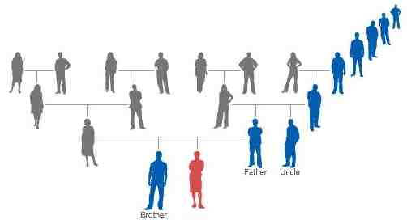

*c/o - Sorenson Molecular Genealogy Foundation*

# Section 8. Epilogue

# Class Notes

#### ***Summary***

Y-DNA can trace the origins of a surname and can be used to find other people who shared an ancestor on this paternal line.

#### ***Access to Materials***

Your Moodle login will continue to be available to you. If you’d like to retake the class, you are welcome to sign up as space is available. No additional donation will be requested (although they are certainly welcome!). Email [DNAAdoptionHelp@gmail.com](mailto:DNAAdoptionHelp@gmail.com) if you wish to re-take this class.

Class Forum

The class forum will be available for follow-up questions for an additional 4 weeks subsequent to the posting of Lesson 3. Participants will also have the option of re-taking this class for free within the next year. Contact [DNAAdoptionHelp@gmail.com](mailto:DNAAdoptionHelp@gmail.com) if you wish to re-take this class.

Stay in Touch! Let us know how your journey is going.

[DNAAdoptionHelp@gmail.com](mailto:DNAAdoptionHelp@gmail.com)

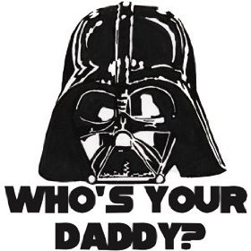

*image c/o - www.superherostuff.com*

I don't want any adoptees or those searching for bio-fathers or NPEs to be offended by this image; my daughter gave me this T-Shirt & I think it's hilarious, even with my own family NPE. I wore it at RootsTech and got great responses.  I think it's a **great** comment on who you've been told all along was your father, and finding out differently.

1. Materials for Section 1 come from Autosomal class developed by Mesa Foard
2. Source: 23andMe.com
3. Unless you’re an identical twin.
4. Source: Blaine Bettinger
5. Source: FT-DNA
6. Source: http://www.isogg.org/wiki/Y_chromosome_DNA_tests
7. Ancestry.com discontinued (and deleted!) their Y-DNA tests and results in August 2014

   <http://www.yourgeneticgenealogist.com/2014/06/ancestrycom-officially-retires-y-dna.html>
8. Source: FT-DNA