

**I've Tested my Y-DNA - What can I expect?**

**Lesson 2. Interpreting your Y-DNA results**

**Objective:** Understand Y-DNA **STR** results and what they mean

**Tools:** This lesson will walk you through the steps required to take the Y-DNA STR test and interpret the results.

* Words and phrases in **bold** indicate important terminology. Please consult the glossary included with the course material.
* Click any entry in the Table of Contents to jump to that part of the lesson.
* Class notes are at the end of the lesson.

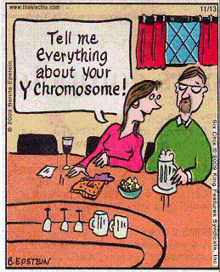

*© 2009 - King Features Syndicate, Inc*

Lesson written by Gale French

Version 1.9 (Feb. 2021)

Layout and Design Gale French, Mesa Foard and Karin Corbeil

© 2014-2021 Gale French, DNAAdoption.org

Contents

Section 1. Ordering & Taking the Y-DNA Test 3

1.1 Your Test Results 3

1.1.1 FTDNA Dashboard Page 3

1.1.2 Matches Page 3

1.1.3 Y-DNA STR Values Page 5

1.1.4 Print Certificates Page 5

1.1.5 Haplogroup Origins Page 6

1.1.6 Haplotree & SNPs Page 7

1.1.6 Phylogenetic Tree 8

Section 2. I got my results - What now? 9

2.1 Results 9

2.1.1 Exact Match 9

2.1.2 Close Match 9

2.1.3 Distant Match 10

2.1.4 No Match 10

2.2 Surprises? 11

2.2.1 N.P.E. 11

2.2.2 Different Surname(s) 11

Section 3. Projects 12

3.1 FT-DNA Projects 12

3.1.1. Surname Projects 12

3.1.2. Geographic Projects 14

3.1.3. Haplogroup Projects 14

3.1.4. Private Projects 14

3.2 World Families Projects 14

Section 4. Glossary 16

Section 5. Resources 19

5.1 Internet 19

5.2 Videos 19

5.3 Books 19

Section 6. Pop Quiz Answers 20

Section 7. Epilogue 21

Class Notes 21

# Section 1. Ordering & Taking the Y-DNA Test

This section is covered in a separate document that was provided in Lesson #1. Refer back if you have not taken the test. The following sections cover your results from a Y-DNA test.

## 1.1 Your Test Results

### 1.1.1 FTDNA Dashboard Page

Once your results are in, you can logon and see your **'Dashboard'** page. For a Y-DNA test you will see your predicted (or confirmed) **Haplogroup** (in this example, **R-YP276** in the lower left) and various buttons to see other information.

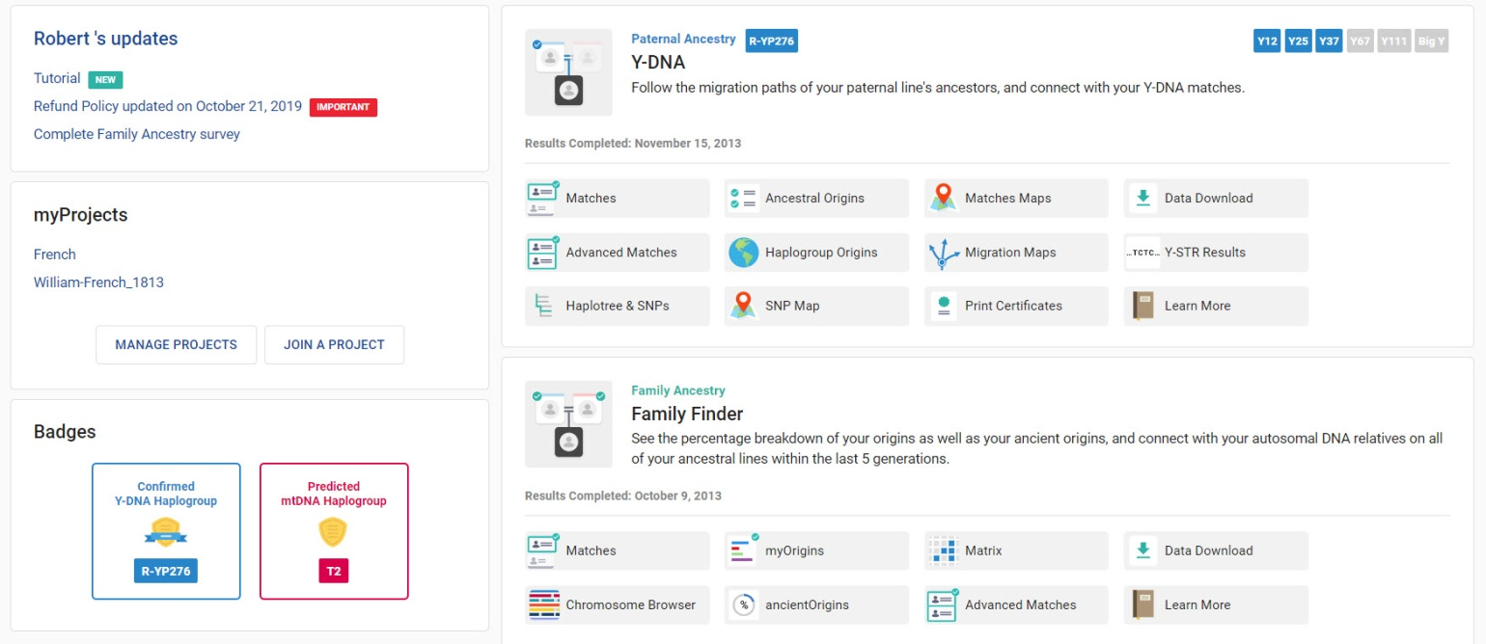

Figure 1 - FTDNA Dashboard page

### 1.1.2 Matches Page

Probably of most interest is the Matches page (see Figure 2). It gives you the name of the match, the number of markers they tested, their Genetic Distance, their **Most Distant Ancestor** known, their Haplogroup and the match date. The columns and their meanings are:



* Genetic distance - GD of this person to you
* Name - name of your match
* Icons & Test Levels - Icons (see next page) and the Y test level (37,67, 111) of this person and other tests (FF, BigY) they have taken
* Most Distant Ancestor - name of their "known" most distant ancestor (based on paper genealogy)
* Haplogroup - Haplogroup for this person
* Terminal SNP - SNP tested farthest down the phylogenetic tree (so far)
* Match Date - date this person was matched to you

**Default Number of Markers**

The default number of markers shown will be the max number of markers that **YOU** tested (e.g., 37 in this case)



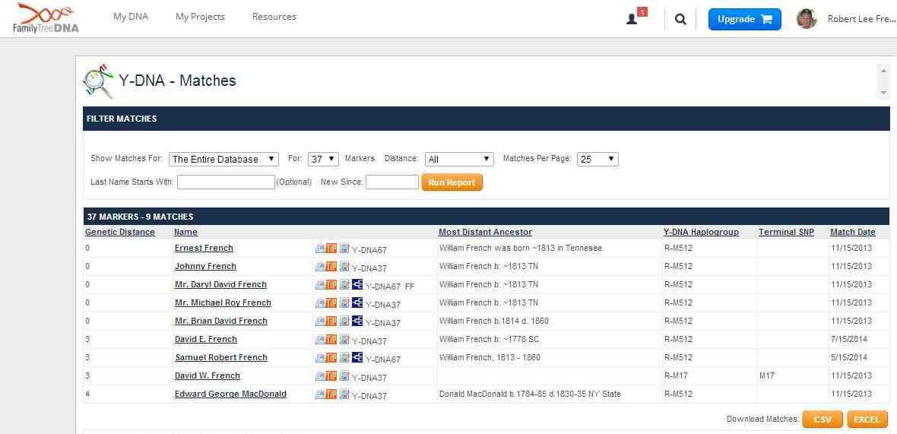

Figure 2 - Matches page

#### Matches Icons

* email - Send this person an e-Mail
* FTDNA Tip - View the TIP Report
* **note -** Add a note about this person
* GEDCOM Viewer - This person has a Family Tree that you can view

**Caution!!**

Is David W. French NOT a match because his Haplogroup is M17? He is a match; Subclades are listed and M17 is a subclade of R-M512

What about Edward MacDonald? He is probably NPE or adopted.



**BigY**

If you have tested up to BigY, your Matches page will look a little different. The 2nd column is BigY STR Differences. In this case, no one in the matches has taken a BigY test (no differences). Big Y is covered in the Advanced Y-DNA class.

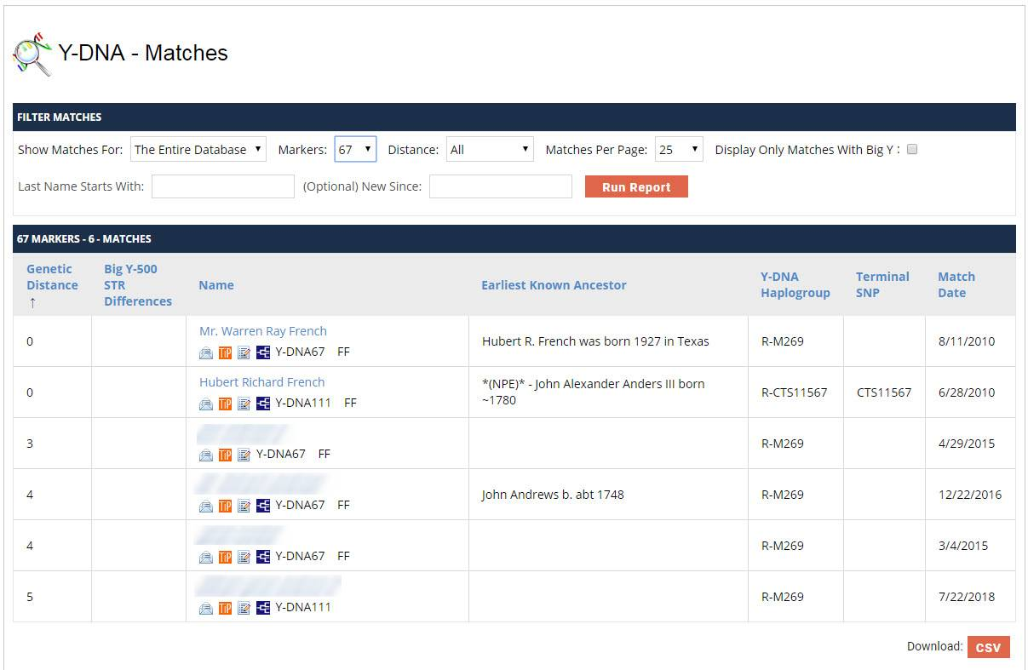

### 1.1.3 Y-DNA STR Values Page

This page (see Figure 3) shows the allele values for each of the DYS markers on your test. This page also allows you to download these values to an Excel or .CSV file (useful if you are keeping your own record of family matches separate from a Surname project).

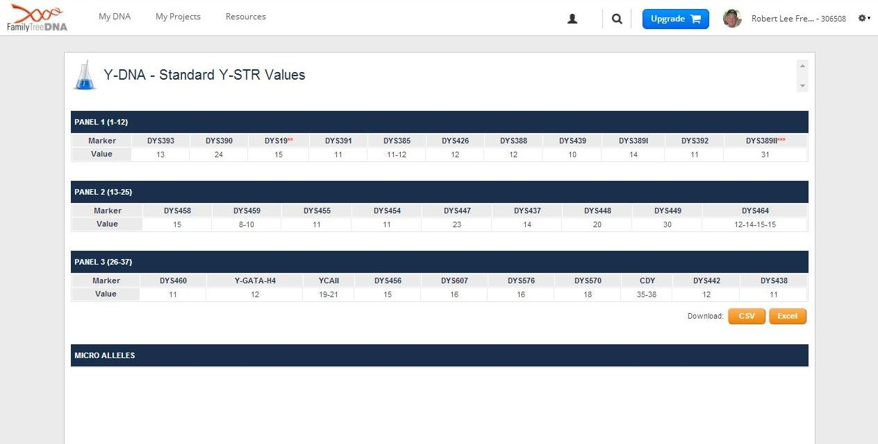

Figure 3 - STR Values page

**Pop Quiz #1**

What is the minimum number of markers that I should test for examining paternal lineage?



### 1.1.4 Print Certificates Page

There are three certificates (PDF files) that you can review/print if you like; the most important (see Figure 4) is the #3 STR results:

1. Understanding Your Results - a document on how to read and comprehend your results
2. Y-DNA STR Certificate - a "pretty" listing of your Y-DNA results
3. Y-DNA Migration Map - a generic map of Haplogroup migration paths

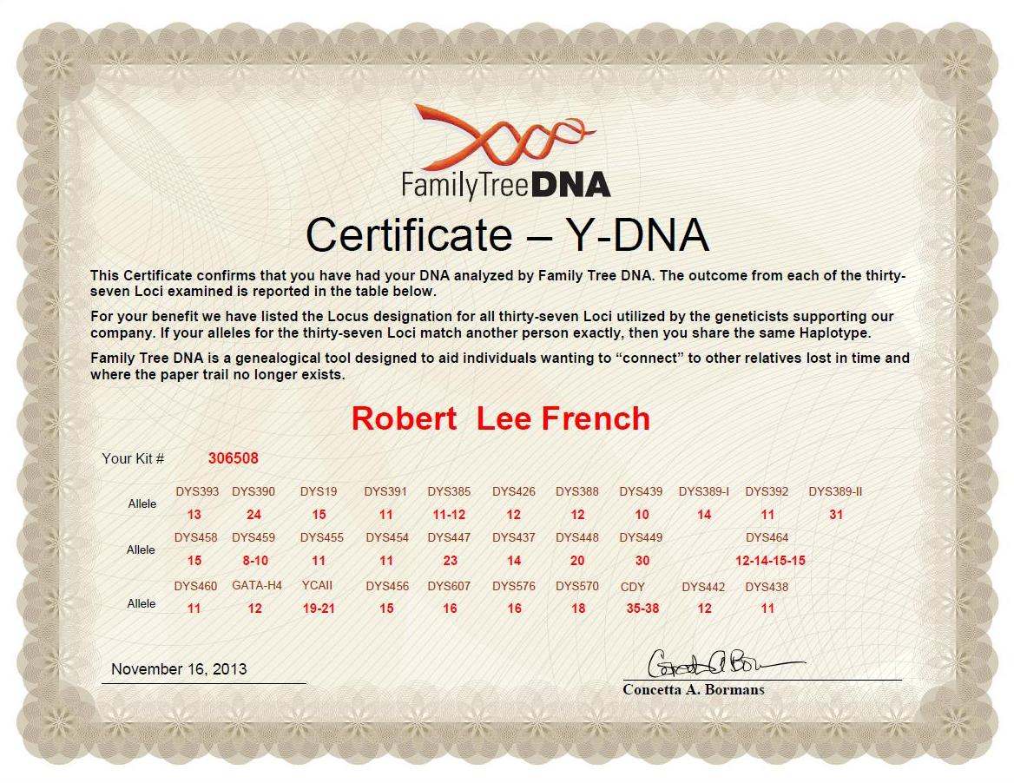

Figure 4 - Print Certificate page

**Pop Quiz #1**

What is the minimum number of markers that I should test for examining paternal lineage?



### 1.1.5 Haplogroup Origins Page

Depending on your Haplogroup, this page tries to narrow down the "country of origin" of the Haplogroup. It shows how many of your matches (exact and different Genetic Distances) are from what countries. Buying additional **SNPs** (Single Nucleotide Polymorphism) will allow you to identify "**sub-clades**" of your Haplogroup (e.g., **R-CTS4179** that means from 'Scotland').

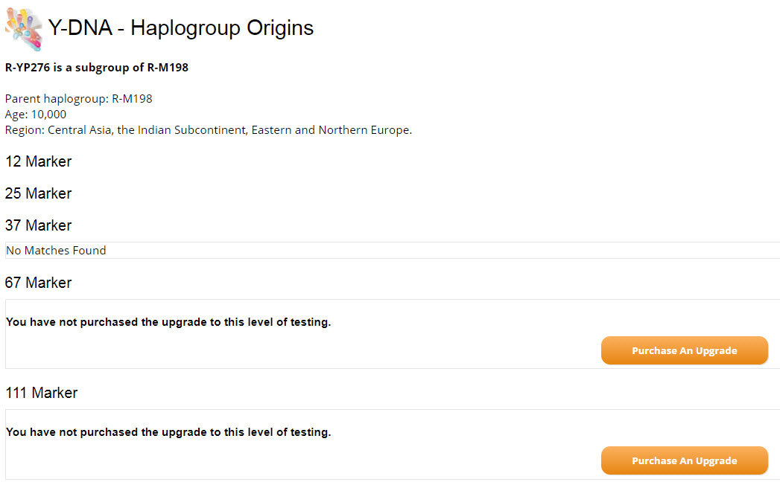

### 1.1.6 Haplotree & SNPs Page

This page allows you to view your Y-DNA SNP results and your Haplogroup information. It tells whether this Haplogroup is 'Confirmed' or 'Predicted'. This is a graphic tree that shows your placement on the current Y‑Chromosome **phylogenetic** tree. In this example, the *confirmed* Haplogroup is R-YP276 (because additional SNP testing has been done). The chart is too big to see it all, so there are two pieces below (top & bottom) to get it all. In this view, if you click on 'R-YP276' at the top you get a Resources menu with more information, like the Public Haplotree which shows you the country origins for each Haplogroup.

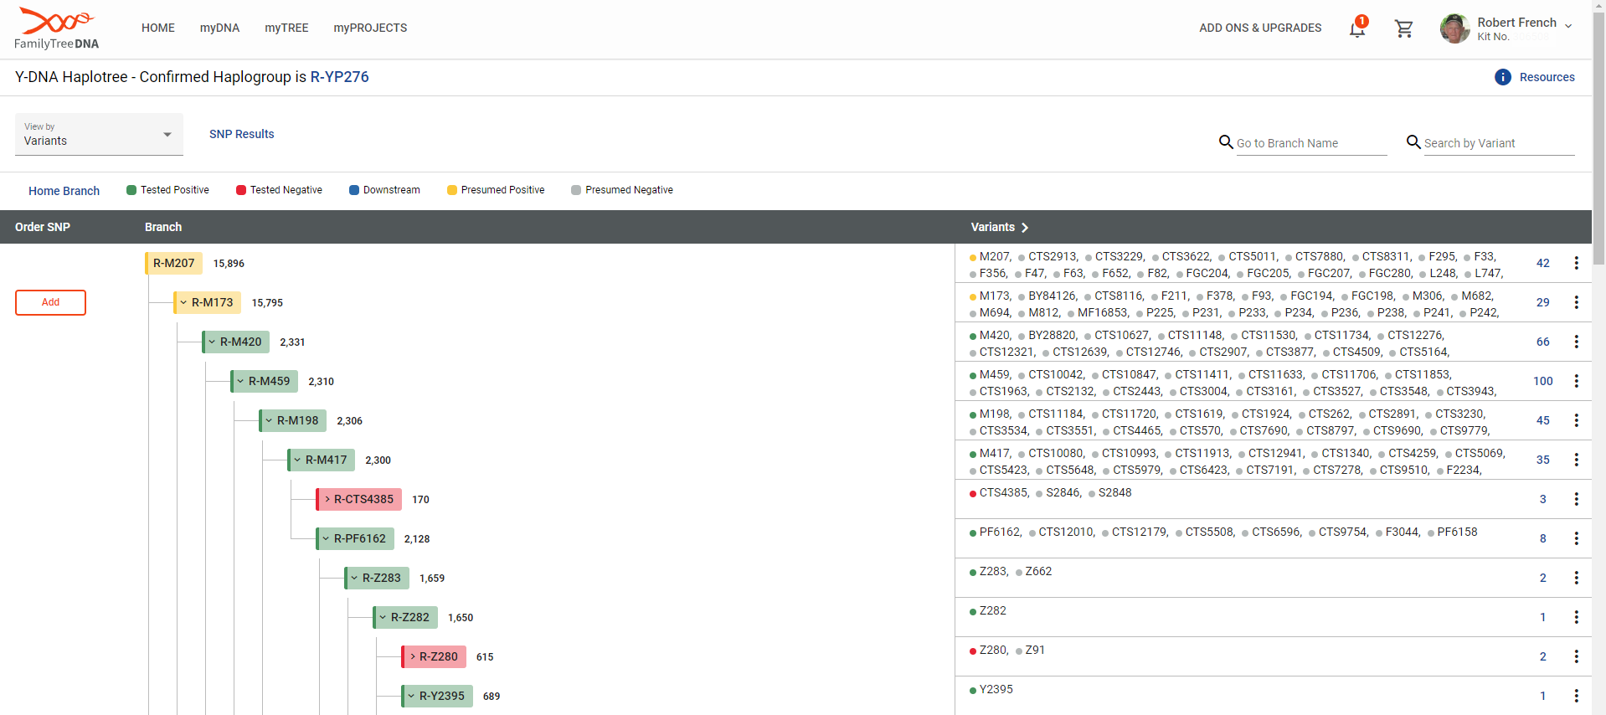

⋮

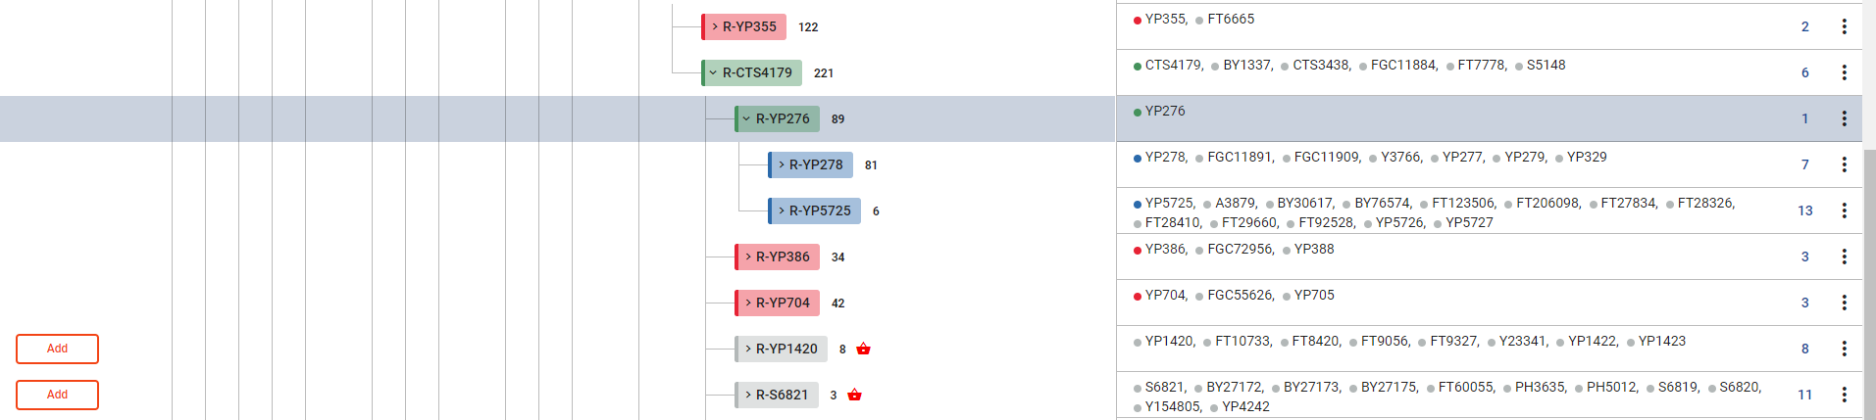

You may order individual SNPs that are part of the official Y-Chromosome Consortium tree for your Haplogroup (red "baskets" next to the SNP indicate that it's part of a SNP Pack). You may also order (if your Haplogroup is 'Predicted') by clicking on the suggested 'Add' buttons for each of the SNPs you wish to test. There are some **SNP Packs** which offer many tested SPs for a discount. If they apply to your Haplogroup, you should see them advertized on this page. SNP testing will be covered in Lesson #3. Your **Project Administrator** (or Haplogroup Project Admin) can usually recommend which SNPs you should test.

### 1.1.6 Phylogenetic Tree

**Project Administrators**

FT-DNA Project Administrators are unpaid volunteers that donate their time and experience to help users understand their results and where they "fit" in the paternal DNA picture puzzle.



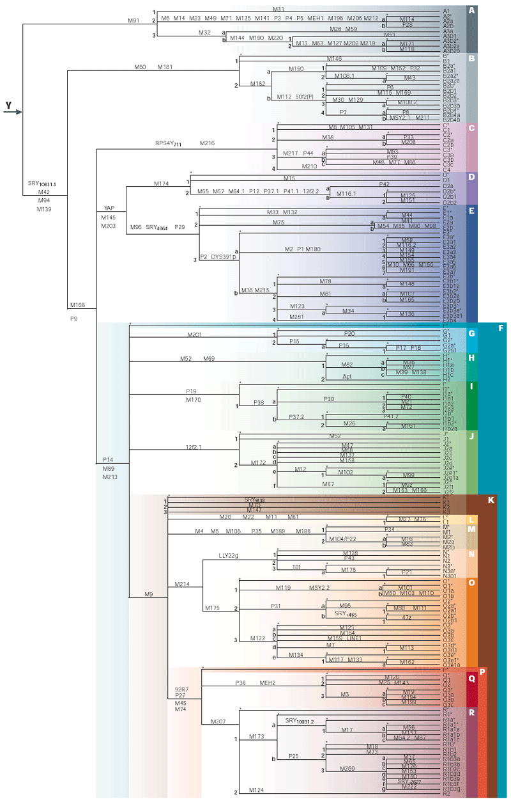

# Section 2. I got my results - What now?

What can I tell by looking at my matches?

## 2.1 Results

When you get your results, you will be in one (or more) of the following categories:

1. Exact match with one or more persons (Genetic distance = 0)
2. Close match with one or more persons (Genetic distance = 1-3)
3. Distant match with one or more persons (Genetic distance = 4-?)
4. No matches at 37 (or more) markers

We will cover what each category means and what to do in each one.

### 2.1.1 Exact Match

This is good! An exact match **verifies** your paternal relationship with that person. The only thing to do here is be happy! You hopefully have met your objective.

### 2.1.2 Close Match

A close match means you are most likely cousins or that you may have had mutations[1] in your family on the fast changing STR markers.

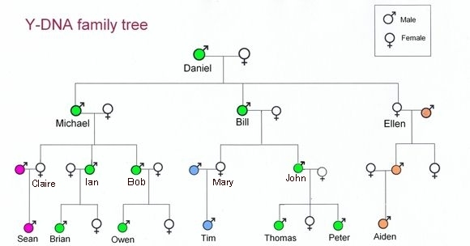

*c/o - http://www.irish-genealogy-toolkit.com*

Every man has one father, two grandfathers, four great-grandfathers, eight great-great-grandfathers, and so on. His Y-DNA comes only from his direct male line. So, while Daniel (at the top) in the diagram above is a perfectly valid great‑grandfather (and MRCA) to each of his ten great-grandchildren (and seven great-grandsons), his Y-DNA can be detected in only **four** of them. However, Y-DNA can change (mutate) between generations, either up or down 1 GD so you may have a 0 and your brother or uncle could have a GD=1. Or it may go unchanged for many generations!

So if you have a close match, contact that person to see who the common ancestor may be (if you don't already know). Ask them for surnames (or a **GEDCOM**) and add them to your tree and find the relationship yourself!

**Pop Quiz #2**

In the '**Y-DNA family tree**' chart above, if Owen and Aiden (2nd cousins) carried out Y-DNA tests, would they be a match?



### 2.1.3 Distant Match

A distance match may mean that you are related farther up the tree than you have researched or discovered. You may have luck at MitoYDNA(covered in Lesson#3 - Tools) extending your tree with a match there. If not, then you will have to work with your distant match contact to find the relationship together (triangulate). See: <http://www.DNAAdoption.org>

### 2.1.4 No Match

If you have absolutely no matches for your surname, it could be the result of one of the following:

1. No one from your surname has tested at FT-DNA. Or they only tested at 25-markers (or less). Wait for (or FIND!) someone else with your surname to also test. Try looking at mitoYDNA.org for matches.
2. An unusual last name that few/none have tested. Use mitoYDNA.
3. There was a surname change in your family in the past. Look for variations in spelling. Again, use mitoYDNA.
4. **N.P.E.** - see Section 2.2.1 on page 11.
5. You didn't meet the threshold to have the match listed. FT-DNA has established match thresholds. For someone to match, they have to meet the criteria[2] for Genetic Distance in the following table:

|  |  |
| --- | --- |
| # Markers Tested | Maximum # Mutations Allowed |
| **12** | **0[3]** |
| **25** | **2** |
| **37** | **4** |
| **67** | **7** |
| **111** | **10** |

One of the things you might try if you tested at 37-markers (or lower) is to upgrade your test to 67‑markers. That might show some matches at a greater distance (5-6) which didn't show up at 37‑markers.

In **all** of the 'No Match' cases, you may also want to do an autosomal test and then concentrate on the matches that you know are on your paternal side (by genealogy or Not **In Common With (ICW)** maternal matches). You may find "cousin" matches that help you go 'up' the tree and back down to your paternal match.

It may take a combination of bouncing back and forth between Y-DNA searching and Autosomal searching to find your paternal ancestor(s). See videos in the **RESOURCES** section (page 19).

dna22

## 2.2 Surprises? MC900436405[1]

Oops! I didn't get the results I thought I would?!? Now what do I do?

## 2.2.1 N.P.E.

**Non-Paternal Event** (N.P.E.) , non-paternity event, false paternal event, false paternity, misattributed paternity; all these terms refer to a break in the Y chromosome line due to a formal or informal adoption, name change, "extramarital event" (infidelity), a child known by other surname (mother's maiden name or stepfather's name). This means a male tested may be carrying the surname but his Y chromosome does not appear to be associated with that surname.

Bennett Greenspan, of Family Tree DNA, states that:

*“any (DNA) project that has more than 20 or 30 people in it is likely to have an 'oops' in it.*

*This aligns well with the traditional belief that anywhere from 5 to 15% of men are not the*

*actual biological fathers of their children. Following this out 10 generations, there is a 40%*

*chance of a non-paternal event!"*

It should be stressed that adoptions were quite common in every age; parents died by disease or war and a relative took in the children and raised them with their name. Daughters had children out of wedlock and the grandparents (or other relatives) raised the children as their own. A teen-age girl who gets pregnant by one boy and marries another, for whatever reason, might be a more frequent occurrence than maternal infidelity in earlier generations. Taking into consideration the strong pressure against "unwed mothers" until the last generation or so, one might expect such cases to account for some of the paternal irregularity indicated by Y‑chromosome testing.

In this case, you need to be looking at the surnames which you **DO** match to determine the actual surname of your ancestor. You can follow the same methodologies as an adoptee might to determine the "truth". See:

<http://www.DNAAdoption.org>

**Pop Quiz #3**

I have a match with Genetic Distance = 3. How can I tell which markers are different (and if they are "fast changing" markers)?



## 2.2.2 Different Surname(s)

You may have surnames that appear on your match list that aren't your last name. Either you (or they) were involved in one of the following

1. Adoption
2. N.P.E. - see above

Additional tests from other family members may be required to see which one (you or them) might have the "wrong" surname.

# Section 3. Projects

## 3.1 FT-DNA Projects

FT-DNA projects are an opportunity to work with others with similar DNA results to explore your paternal genetic heritage. Membership is **FREE** and voluntary. You may join or leave a project at any time. You may join as many projects as you wish:

1. Surname
2. Geographic
3. Haplogroup
4. Private

If you ordered your test through a surname project, you are already a member of that project.



### Surname Projects

Your results will automatically be reported to the Project Administrator for your surname. They may do some analysis and processing to determine if your results match a particular "Group" of results with similar Haplogroups and/or Common Ancestor names. Reach the group by clicking on one of your Projects from your 'My DNA' page (see Figure 1 - FTDNA Dashboard page on page 3) or by searching through the surname projects page (from Lesson #1). You'll see a page describing the project with links to results of various kinds.

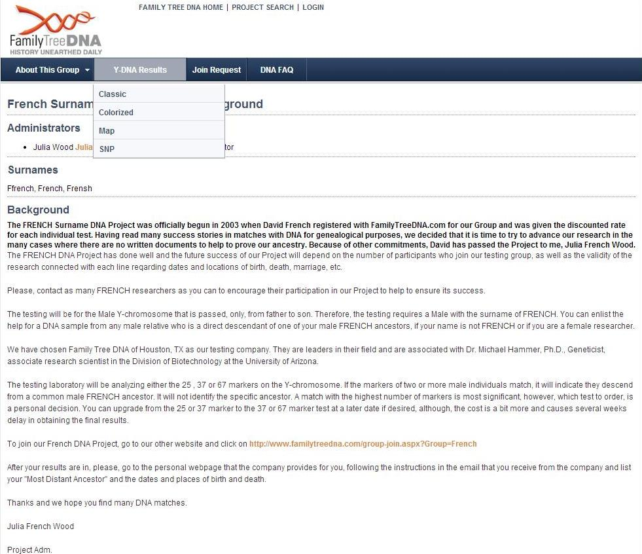

#### Surname Project Results

The most exciting data in the surname project lies in the Y-DNA Results page. Here you see the entire list of people that have tested for this surname. They have usually been grouped with members with similar characteristics. Some also color code the differences in allele values by highlighting them.

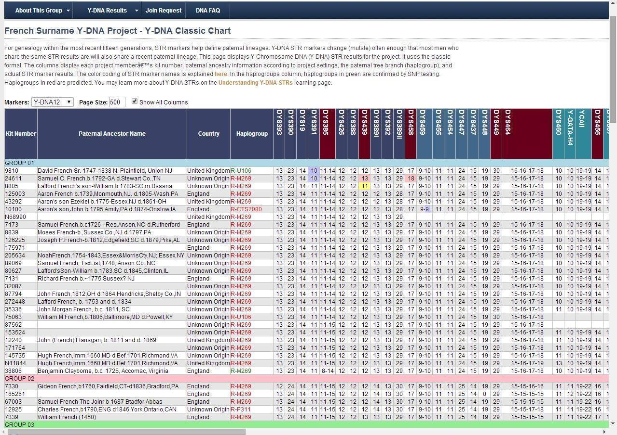

**Pop Quiz #4**

If I have a highlighted allele value on one or more of my markers, can my Genetic Distance be zero?



The color codes for the DYS headers at the top of the page are explained in the following chart:

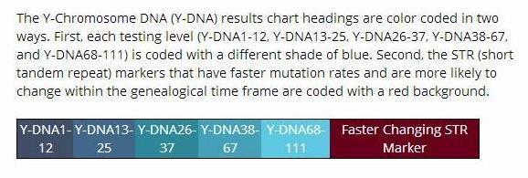

If you look at the color coding across the top of a FT-DNA Surname Project sheet, you will see the maroon colored markers are the 'fast' mutating ones. They are in the following groups:

* 1-12: 3 (DYS385 (2x) & DYS439)
* 13-25: 6 (DYS458, DYS449 & DYS464 (4x))
* 26-37: 5 (DYS456, DYS576, DYS570 & CDY (2x))
* 38-67: 5 (DYS413 (2x), DYS557, DYS481 & DYS446)
* 68-111: 0

So you can see that a 37 marker test will show you most of the mutations (thus Genetic Distance) and 67 markers will show you ALL of the fast changing markers (not to say you won't have "regular" mutations in the 68-111 range).

### Geographic Projects

These projects look at specific regions of the world to see how the residents in that area, or those who trace their ancestry to specific regions, relate genetically.

### Haplogroup Projects

These study a particular Haplogroup, and they are the best resource for determining what type of SNP test to get and what those results mean.

### Private Projects

Private Projects are for people who manage multiple kits or are interested in a specific family lineage. Private projects require approval from FT-DNA.



## World Families Projects

Some Surname Projects at FT-DNA were hosted at WorldFamiles.net. The E.U. GDPR regulations in 2018 caused the shutdown of this site. Many of these have gone back to FT-DNA hosting.

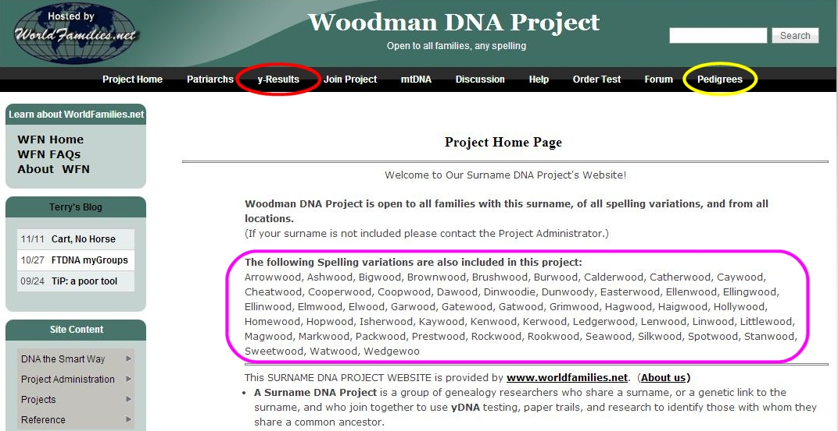

# Section 4. Glossary [4]

* **Allele** - One of the possible values for a marker. For example, with Y chromosome DNA, the values of "13" or "14" would be different alleles for DYS393.
* **Base** - A base is a unit or building block of DNA. Adenine (A), cytosine (C), guanine (G), and thymine (T) are the four primary bases in DNA. The order of bases is the sequence of DNA.
* **EKA - E**arliest Known **A**ncestor
* **Genetic Distance** - Genetic Distance is the number of differences, or mutations, between two sets of results. A genetic distance of zero means there are no differences in the results being compared against one another. See following pages for 11 markers.

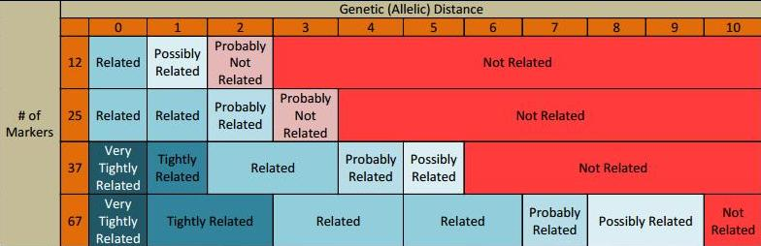

* **Haplogroup** - A Haplogroup is a major branch on either the maternal or paternal tree of humankind. Haplogroups are associated with early human migrations. Today these can associated with a geographic region or regions.
* **Haplotype** - A haplotype is the set of DNA values. For example, the results of the Y‑DNA12 test for one person are their haplotype.
* **Marker** - A marker is a physical location (locus) on the chromosome. The term is often used colloquially in genetic genealogy to refer to a short tandem repeat (STR).
* **Most Distant Ancestor** - the person along your paternal line that your paper research shows as the "oldest" male ancestor you have found
* **Most Recent Common Ancestor (MRCA)** - the most recent ancestor from which the two individuals descended
* **Non-Paternal Event (N.P.E.) -** a break in the Y chromosome line due to adoption (legal or 'common'),, infidelity or numerous other causes.
* **Project Administrator -** a volunteer genetic genealogist who can help users understand their DNA results
* **Short Tandem Repeat (STR**) - A short DNA motif (pattern) repeated in tandem. ATGC repeated eleven times would give the marker a value or allele of 11.
* **Sub-clade** - term used to describe a subgroup of a subgenus of a Haplogroup.
* **Y-Chromosome** - One of the two sex chromosomes, X and Y. The Y-Chromosome passes down from father to son. Females do not receive it. As the Y-Chromosome is passed on through the paternal line, it is valuable for surname based genealogy studies.
* **Y-DNA Backbone test** - If a person’s Y-DNA Haplogroup cannot be predicted with 100% confidence, the SNP Assurance Program at FTDNA will test your sample with our Backbone SNP test for FREE. This test is a "deep" multiple SNP test. Specifically, if we cannot predict a person’s Y-DNA Haplogroup with sufficient confidence that they can join the National Geographic’s Genographic Project, we will automatically perform a Backbone SNP test in order to identify the Haplogroup assignment. Backbone tests take about 6-8 weeks from the time they are ordered.
* <https://dnaadoption.org/acronyms/>

<https://dnaadoption.org/glossary/>

**Genetic Distance Table for 111 markers**

# GD@111Section 5. Resources

Once you have clues to people who might match your DNA, there are gold mines of resources just waiting to help you move farther along in your search.

## 5.1 Internet

* The resources we’ve used in class, of course: [FamilyTreeDNA.com](http://www.familytreedna.com/).
* <https://www.familytreedna.com/learn/using-the-kit/family-tree-dna-test-kit/>
* <https://www.familytreedna.com/learn/dna-test-kit-instructions/>
* <https://www.familytreedna.com/learn/using-the-kit/use-swabs/>
* ISOGG: <http://www.isogg.org>
* BLOGS: <http://dna-explained.com/2014/09/04/what-does-and-doesnt-a-y-dna-match-mean/>
* There are many surname project websites, often associated with Y-DNA tests. Here’s one example: <https://www.familytreedna.com/public/French?iframe=yresults>
* If you haven’t found what you want yet, visit Cindy’s List <http://www.cyndislist.com/> for an incredible list of genealogy resources organized by category.

## 5.2 Videos

* <https://www.youtube.com/watch?v=AN07Adpu7Bs> How to Take a Family Tree DNA Test (4:10)
* <https://www.youtube.com/watch?v=ekB9LY_aL04> Family Tree DNA Results Explained: Y-DNA Markers, Matching & Genealogy (FT-DNA Webinar 1:55:40)

* <https://www.youtube.com/watch?v=zy0QnSLnFtw> How to enhance your Y-DNA results through Surname and Haplogroup projects (1:11:42)
* <https://www.youtube.com/watch?v=qiv0Ny6nvAY> Help, My Y-DNA Matches Have a Different Surname! (FT‑DNA 1:29:56)
* <https://www.youtube.com/watch?v=Wicb2_bEIYo> Adoptions & illegitimacies - using DNA to solve adoption mysteries (Dr. Maurice Gleeson 1:03:40)

## 5.3 Books

* Bettinger, Blaine T. - " ***Guide to DNA Testing and Genetic Genealogy"***  ©2016, Family Tree Books, Cincinnati, OH [ISBN-13: 9781440343326 9781440345395] *<< available as book or e-Book>>*
* Aulicino, Emily - "***Genetic Genealogy: The Basics and Beyond***", ©2014, AuthorHouse LLC, Bloomington, IN [ISBN13: 9781491840900]
* Smolenyak, Megan & Turner, Ann - "***Trace Your Roots With DNA: Use Your DNA to Complete Your Family Tree***", ©2004, Rodel Books, New York [ISBN 1594860068 (ISBN13: 9781594860065)]
* Pomery, Chris - "***DNA and family history : how genetic testing can advance your genealogical research***", ©2004, Dundurn Group, Toronto, Ontario
* Dowell, David R. (Ph.D.) - " ***NextGen Genealogy: The DNA Connection***", ©2015, Santa Barbara, California : LIBRARIES UNLIMITED, an imprint of ABC-CLIO, LLC
* Hill, Richard - "***Finding family : my search for roots and the secrets in my DNA***", ©2012, Richard Hill (self published), Grand Rapids, Michigan. *<< available as book or e-Book>>*
* Griffeth, Bill- "***The Stranger in My Genes***", ©2016, UPNE Book Partners, Lebanon, NH [ISBN-13: 978-0-88082-344-9]

# Section 6. Pop Quiz Answers

1. 37 - Test only what you need (or can afford) and upgrade when necessary. The following chart shows the times back to the **Most Recent Common Ancestor (MRCA)** when **ALL** the markers match. So you get more "bang for the buck" by testing 37 markers in order to identify (or verify) most recent ancestors. I get a 90% chance of MRCA in **6-7** generations with Y-37 where a Y-12 test takes **30** generations for the same result!!

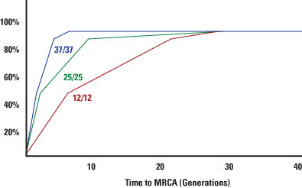

Remember from Lesson #1, with 37/37 (all 37 markers match), there is a 50% probability that the MRCA was no longer than 2 generations past, and a 90% probability that the MRCA was within the last 5 generations.

1. No. Aiden got his Y-DNA from Ellen's husband (in orange). If you choose a different pair of cousins – (Brian and Owen) or (Brian and Thomas) it would show them related on the same paternal line.



1. The only way to see the STR markers of your matches is in the Surname Project (if they have joined). Use the browser 'Search' to find his kit number or **EKA** name. There, he has been grouped with "like" markers/Haplogroups and you can see the values for each marker. If you look at the 'colorized' version it will highlight the differences in markers in the group. Then you can see if the differences were on fast changing markers.
2. No. With each highlighted difference, that increases your Genetic Distance (by one or more!). See definition of Genetic Distance in the Glossary.

# Section 7. Epilogue

# Class Notes

#### ***Summary***

Y-DNA can trace the origins of a surname and can be used to find other people who shared an ancestor on this paternal line. Y-DNA Testing is the process of getting your Y-Chromosome results for comparing with other testers.

#### ***Access to Materials***

Your Moodle login will continue to be available to you. If you’d like to retake the class, you are welcome to sign up as space is available. No additional donation will be requested (although they are certainly welcome!). Email [DNAAdoptionHelp@gmail.com](mailto:DNAAdoptionHelp@gmail.com) if you wish to re-take this class.

Class Forum

The class forum will be available for follow-up questions for an additional 4 weeks subsequent to the posting of Lesson 3. Participants will also have the option of re-taking this class for free within the next year. Contact [DNAAdoptionHelp@gmail.com](mailto:DNAAdoptionHelp@gmail.com) if you wish to re-take this class.

Stay in Touch! Let us know how your journey is going.

[DNAAdoptionHelp@gmail.com](mailto:DNAAdoptionHelp@gmail.com)

i

1. Bennett Greenspan, CEO of FT-DNA has a GD=1 with his father!!
2. FamilyTree DNA
3. If while in the FT-DNA match list, you go from higher markers (37 or 67) down to 12 markers, you may see it show a GD=1. This is a remnant of showing the higher markers. It won't initially show a 12 marker match >0.
4. **NOTE:**  the Glossary "grows" with each lesson (and includes definitions from previous lessons) so that you don't have to go back to other Lessons to get definitions.