

**Ordering & Taking the Y-DNA Test**

## Section 1. Ordering the Y-DNA Test

*Here’s a step-by-step process to take your Y-DNA test.*

## Go to FT-DNA

Start your browser and go to FamilyTree DNA ([FamilyTreeDNA.com](https://www.familytreedna.com)). Click on the 'Projects' tab at the top of the screen and then click on the 1st letter of your surname. Search to see if there is a Surname Project for your surname.

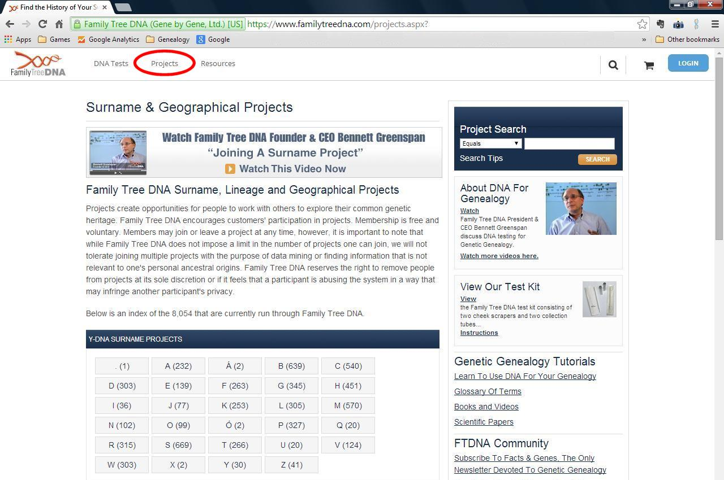

Lesson written by Gale French

Version 1.1 (Jan. 2018)

Layout and Design Gale French

© 2019 Gale French, DNAAdoption.org and DNAGedcom.com

Either search for your surname or scroll down the list to browse through all the names.

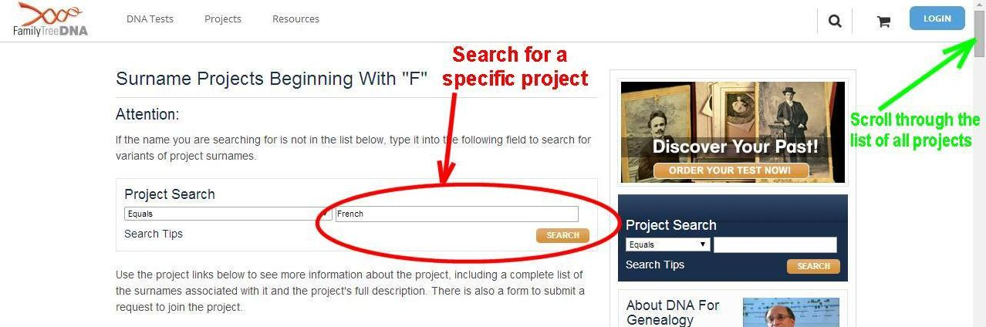

**Discount!!!**

When you order your test through a Surname Project, you get a **discounted** price!



# Surname Project

Members of a Surname project get a discount for ordering though the project.

|  |  |
| --- | --- |
| French Surname Project | Test Prices |

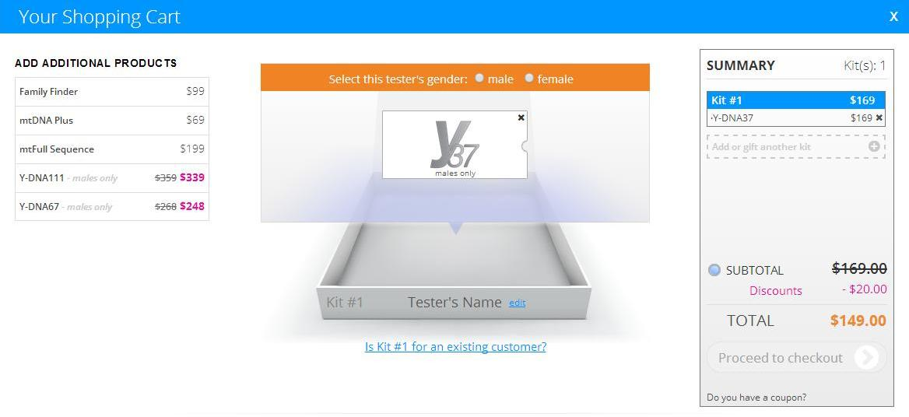

# Section 2. Taking the Y-DNA Test

You will get an e-Mail confirming your order (with your Kit# and password). And now you wait!

## 2.1 What to Expect - your kit

A kit is for use by one person. It consists of two swabs, two tubes, instructions, the release form and a padded return envelope.

|  |  |
| --- | --- |
|  |  |
| https://www.familytreedna.com/learn/wp-content/uploads/2014/01/SnapOffSwab-1024x115.png | https://www.familytreedna.com/learn/wp-content/uploads/2014/01/plungerswab.png |

## 2.2 The Cheek Swab

It is recommended that you wait 1 hour after eating or drinking to take the test! Detailed instructions:

[**https://www.familytreedna.com/learn/dna-test-kit-instructions/**](https://www.familytreedna.com/learn/dna-test-kit-instructions/)

Each swab will have a cotton ‘toothed’ tip or rounded "snap-off" swab (depending on when you ordered the kit). Using it feels like brushing your inner cheek with your toothbrush. A good scrape produces lots of DNA. This makes the DNA extraction process easier.

Follow all the instructions! There is a great You-Tube video showing someone performing a DNA test:

[**https://www.youtube.com/watch?v=q_ErJy8RNDQ**](https://www.youtube.com/watch?v=q_ErJy8RNDQ)

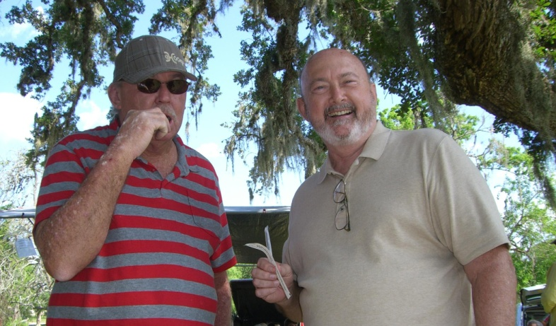

Figure 1 - Family Reunions are a great place to get relatives to test!

## 2.3 Return

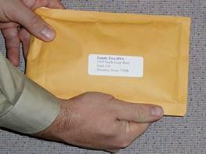Once you have done both swab tests, fill out and sign the release, pack the bag with the tubes and release form then mail it back. The current test kits come with return postage included (for kits in the **U.S.** only)!

# Section 3. Y-DNA Results

You will get an e-Mail that your kit was received. And now you wait some more!

## Order History 3.1 Get a Projected Date

You can get an estimated time for your results by logging on to FT‑DNA and clicking on the **'Complete Order History**' link.

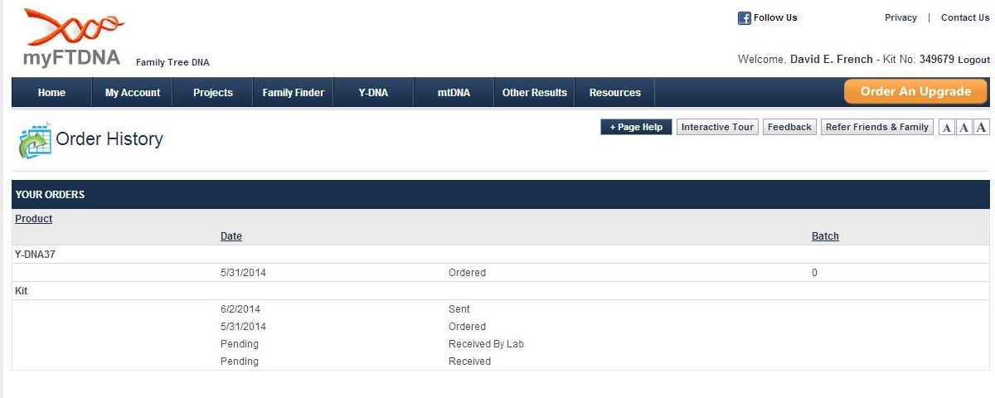

**What to do while you wait**

While you wait for your results to come in, stay busy with these activities:

* Get your "paper" genealogy data for your paternal line in order
* Think of other male family members to test to meet your objective(s)
* Study Y-DNA resources listed here and others on the Web
* Fill out your personal profile on FT-DNA
* Fill out your personal profile on FT-DNA



## 3.2 Results e-Mail

Soon you will get an e-Mail that your results are in; you may get partial results if you are getting a large number of **markers** tested (e.g., 38-47 of 67).

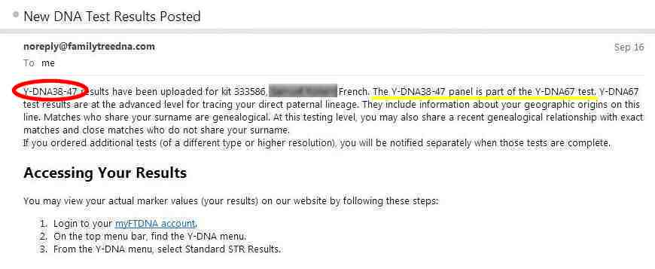

## 3.3 Your Test Results

### 3.3.1 My DNA Page

Once your results are in, you can logon and see your 'My DNA' page. For a Y-DNA test you will see your **Haplogroup** (in this example, R-M512) and various buttons to see other information.

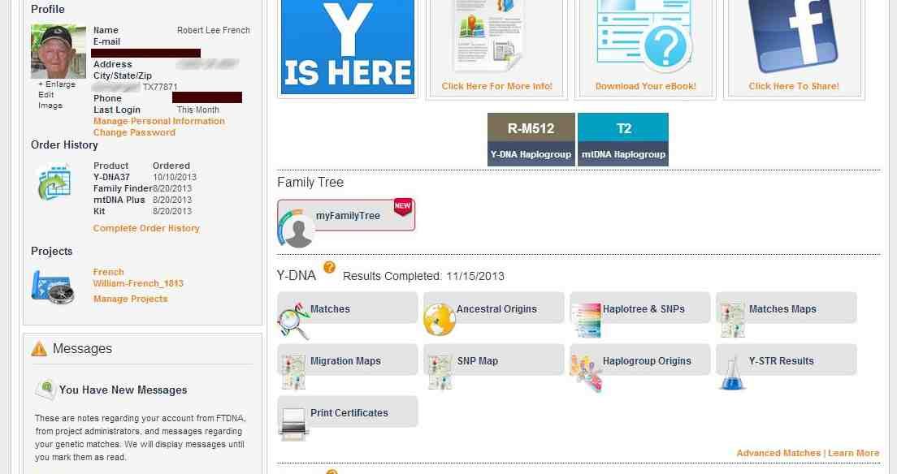

Figure 2 - My DNA page

### 3.3.2 Next

The information on what to do with your results is presented in the Y-DNA Class. Sign up **NOW**!